16) Greedy Algorithms
1) Activity Selection Problem -
2) Pair in C++ : STL container to store 2 objects -
3) Fractional Knapsack Problem -
4) Minimum Absolute DIfferent Pairs -
5) Maximum Chain Length of Pairs -
6) Indian Coins Problem -
7) Job Sequencing Problem –

Generally Jaha Quns me Maximum/minimum use ho rhe hote h and apart from Array, String(maxisum subarray, substring,subsequence,maxsu,minsum) then most probably chances for the application of => Greedy Algo's.

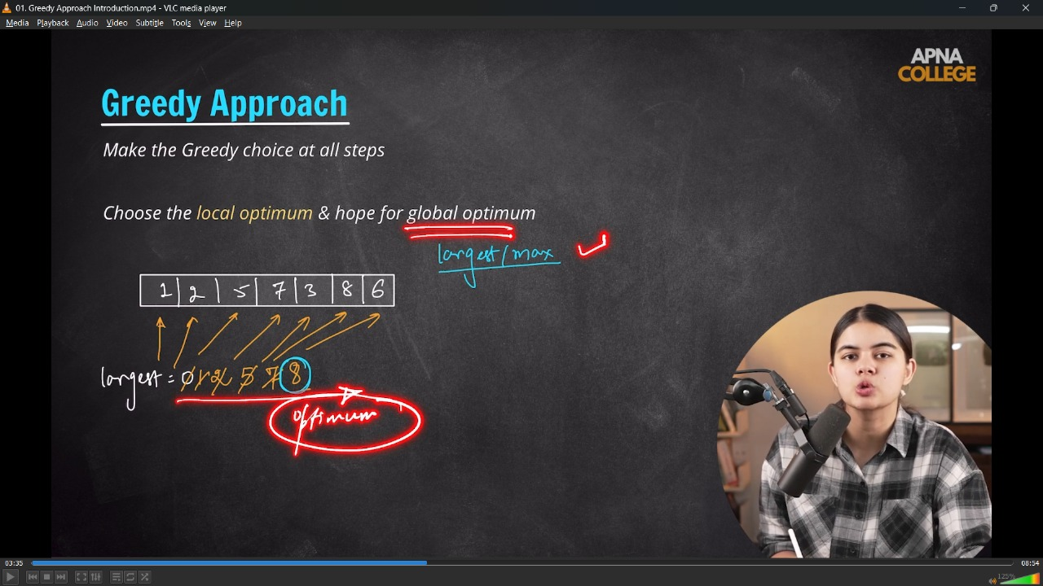

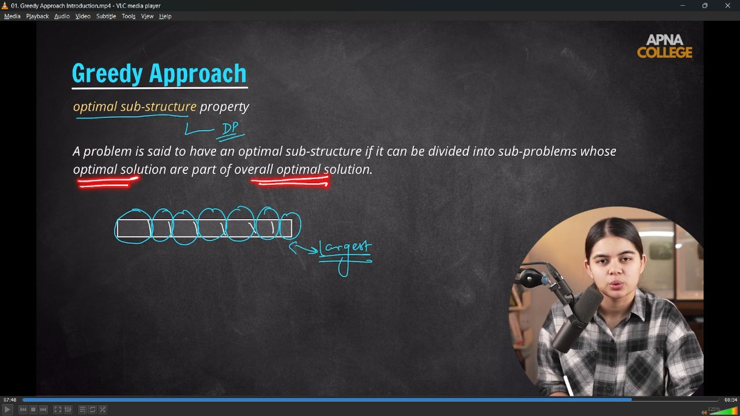
// 1) Activity Selection Problem -
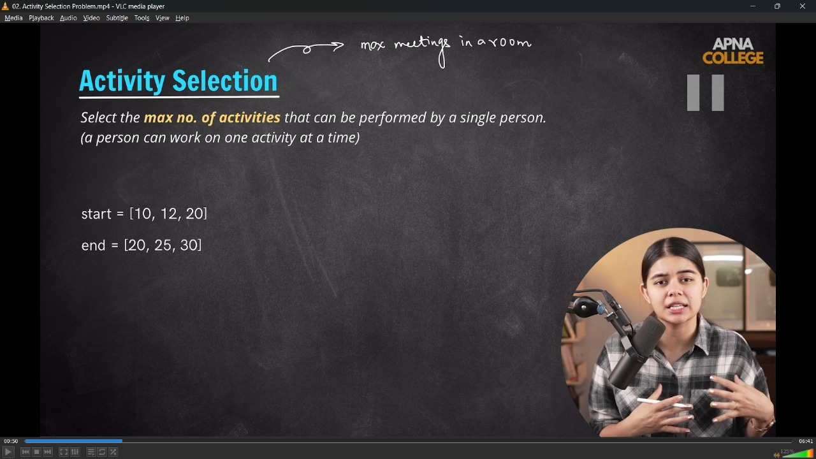
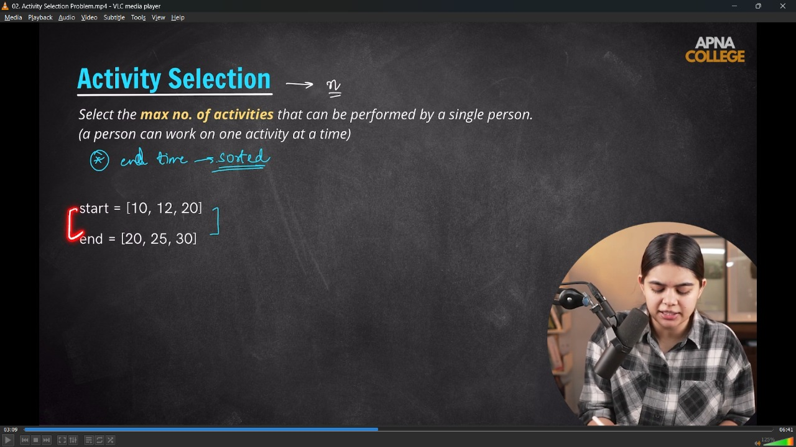
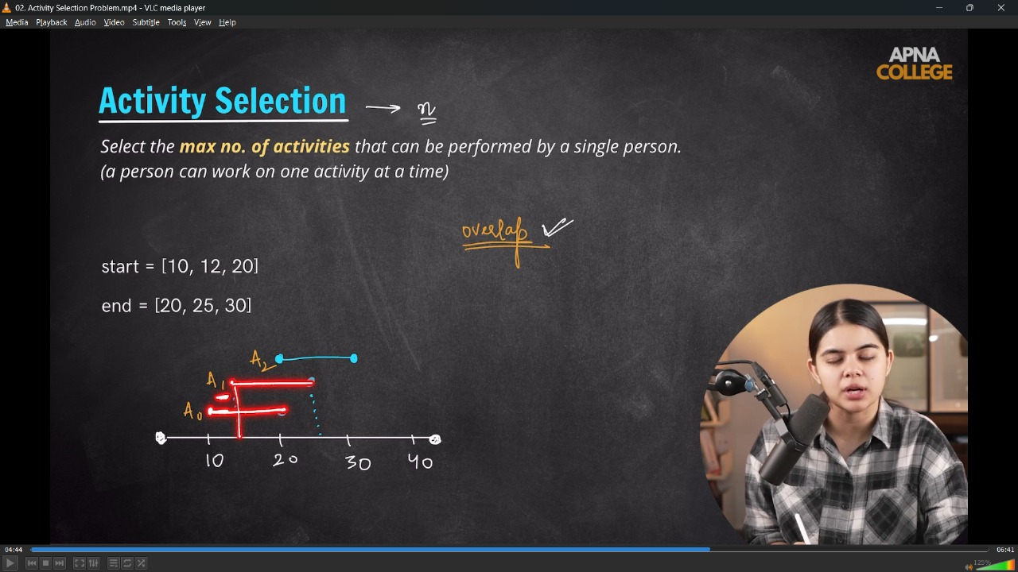
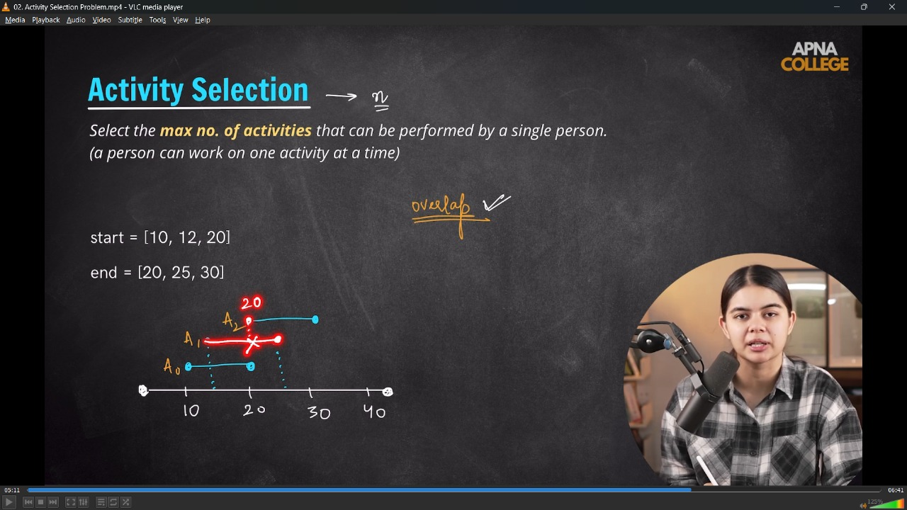
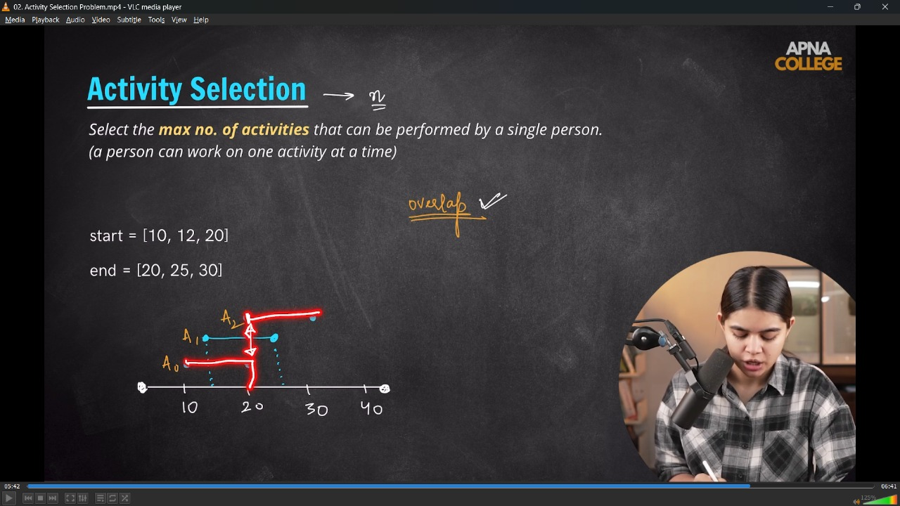
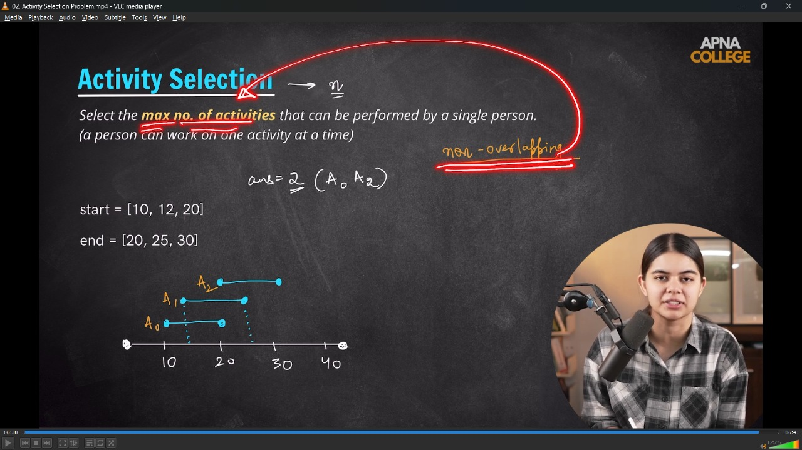
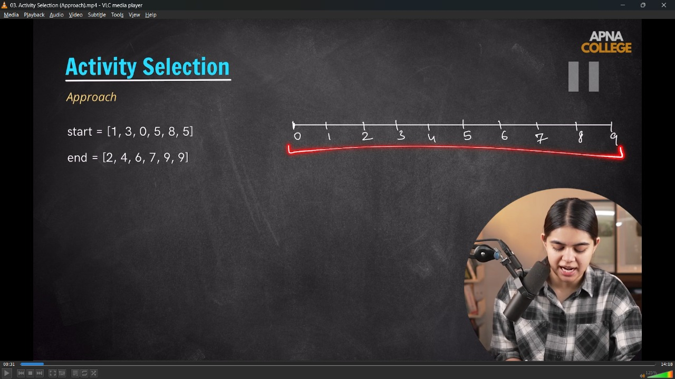
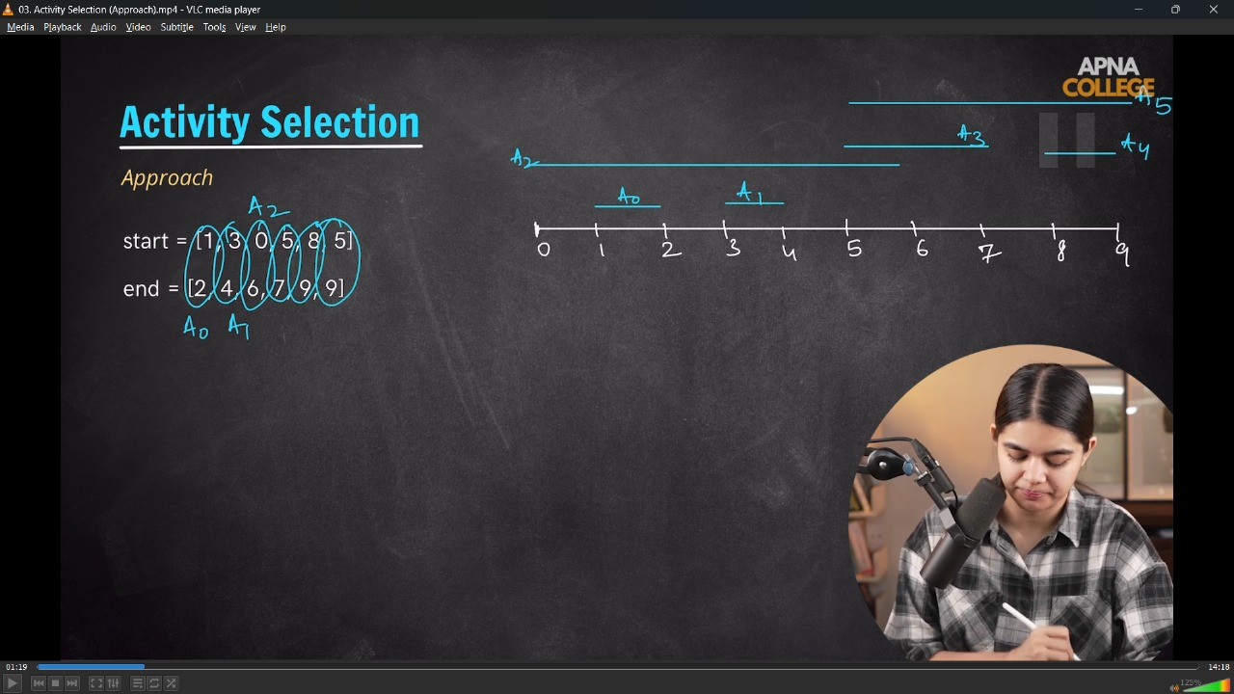
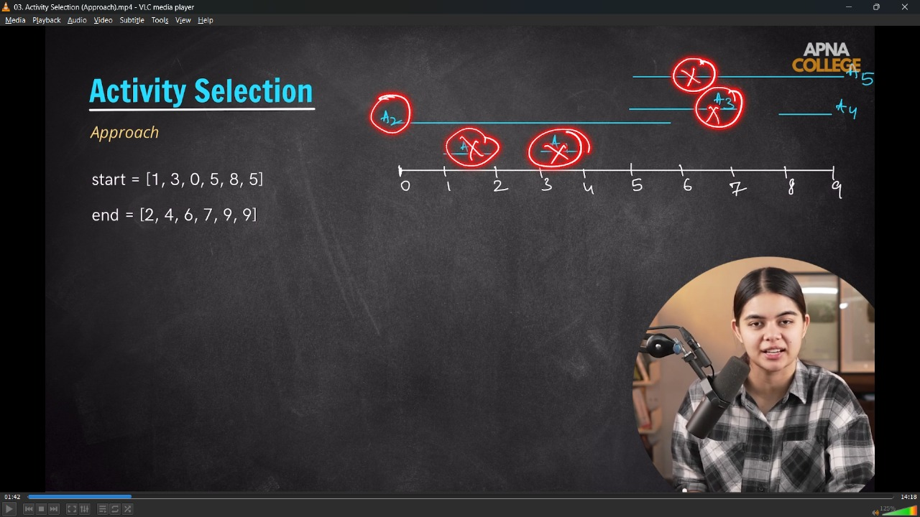
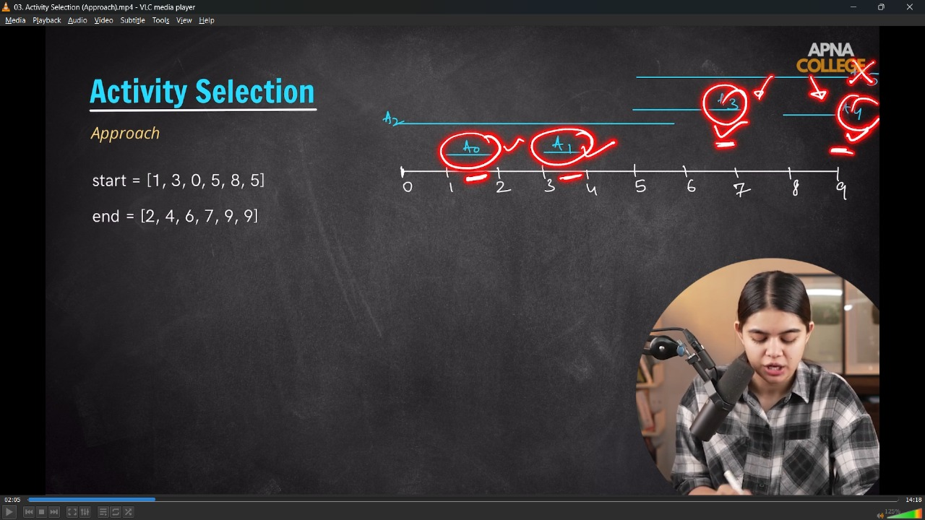
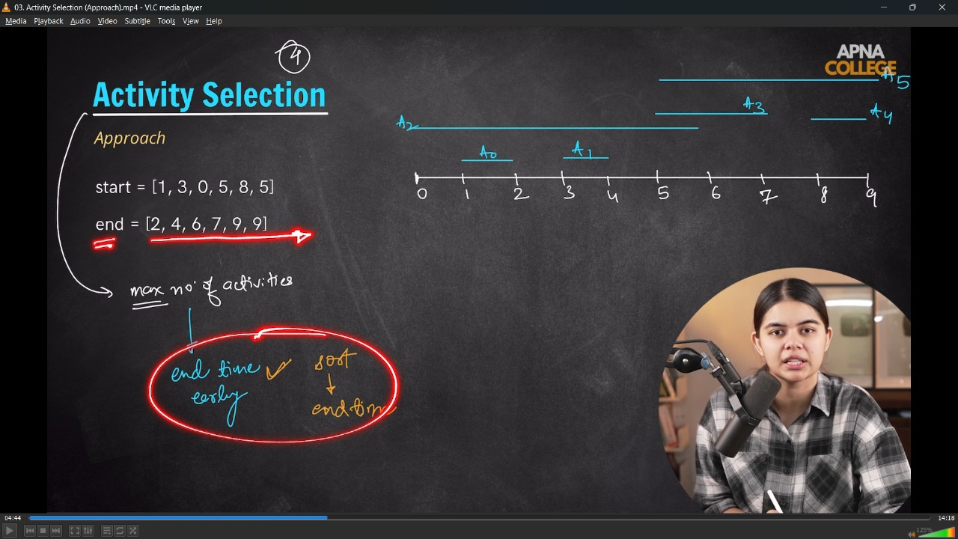
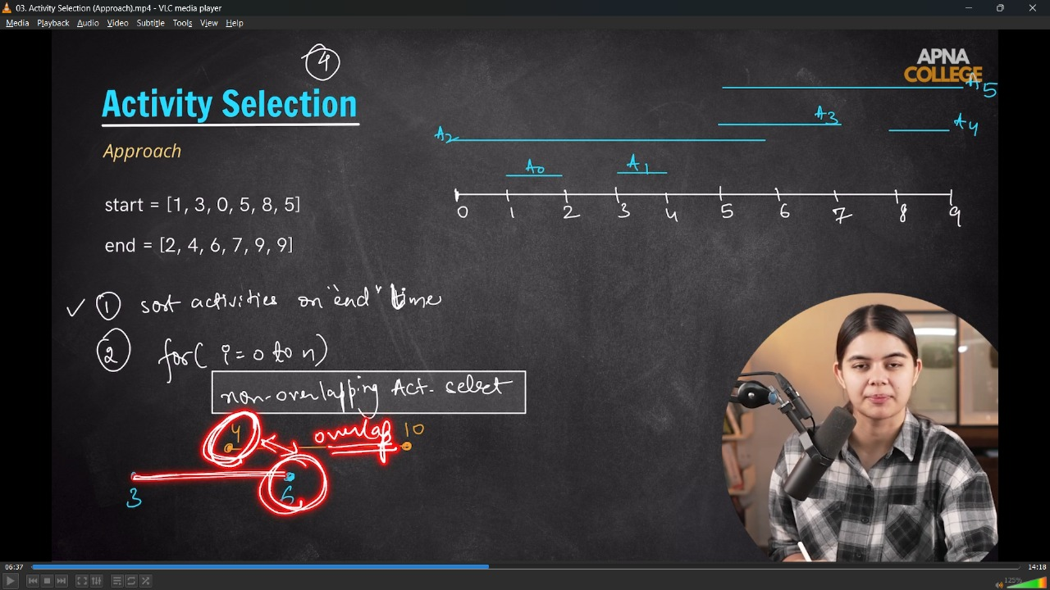
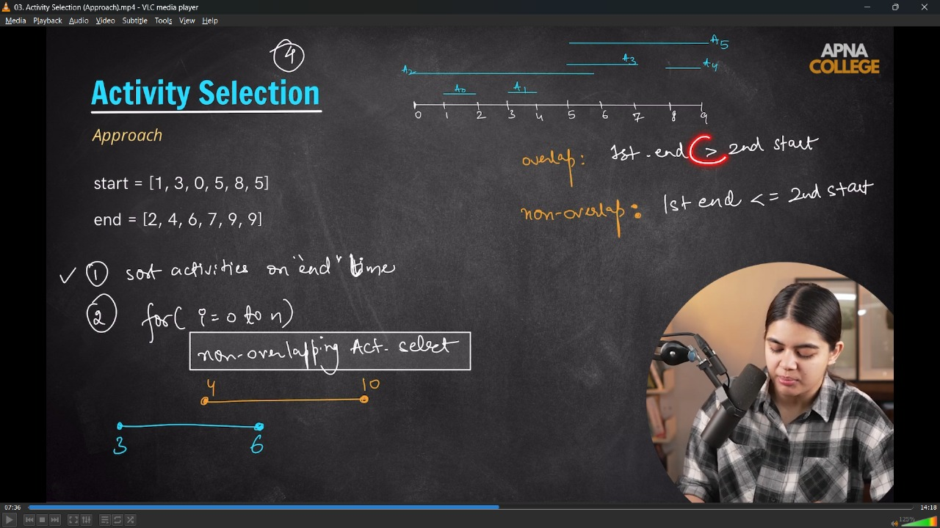
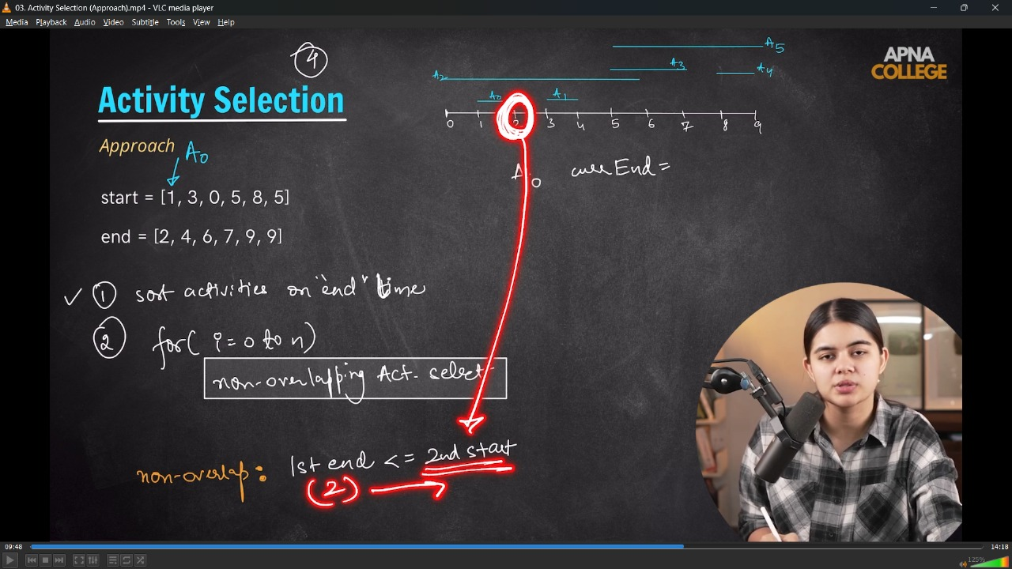
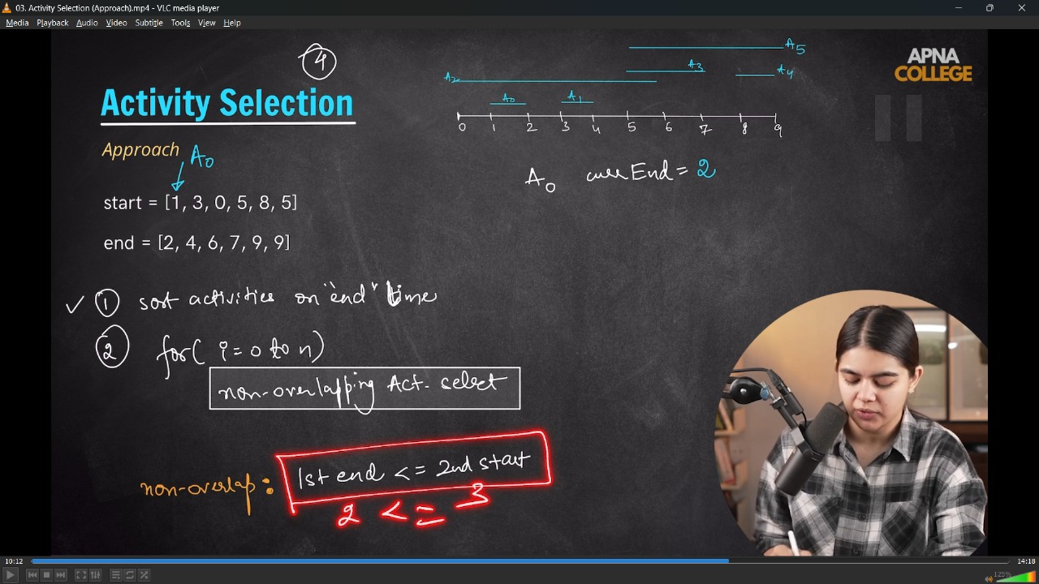
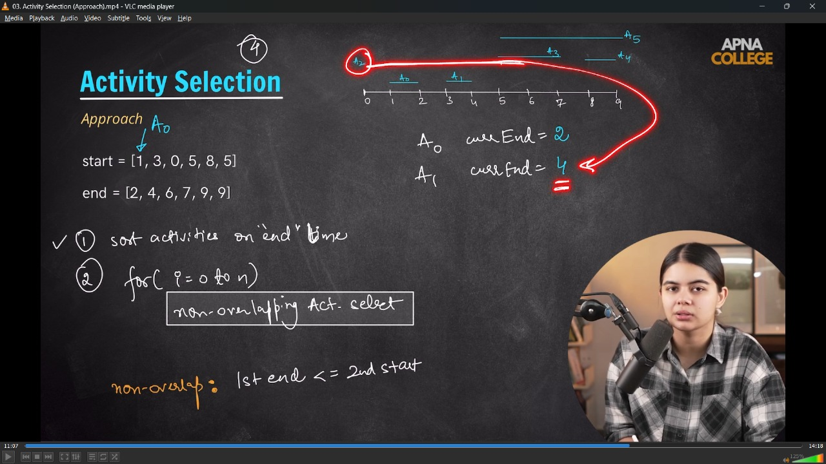
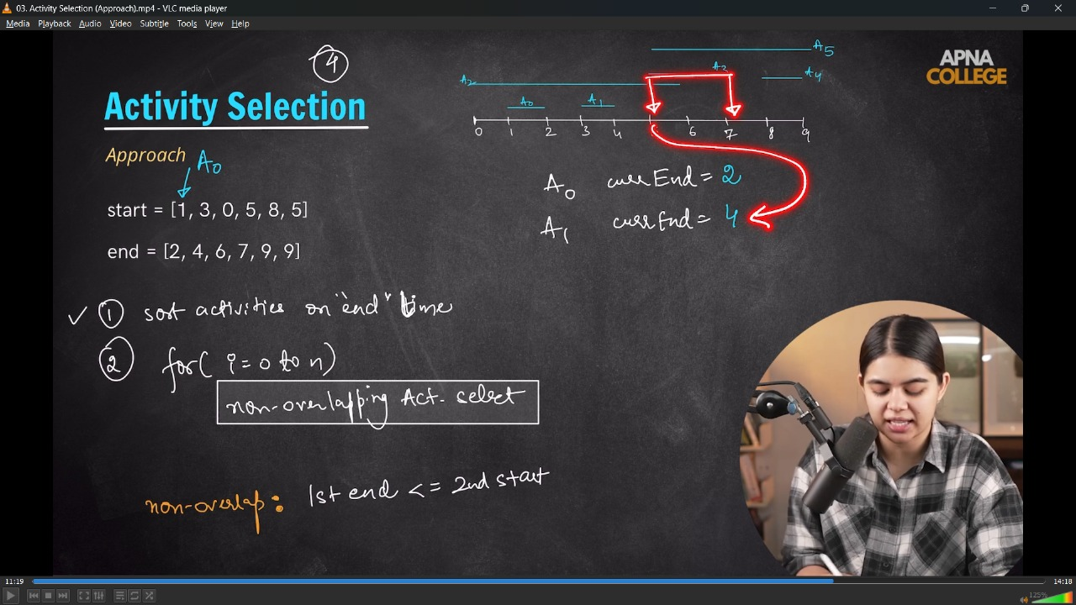
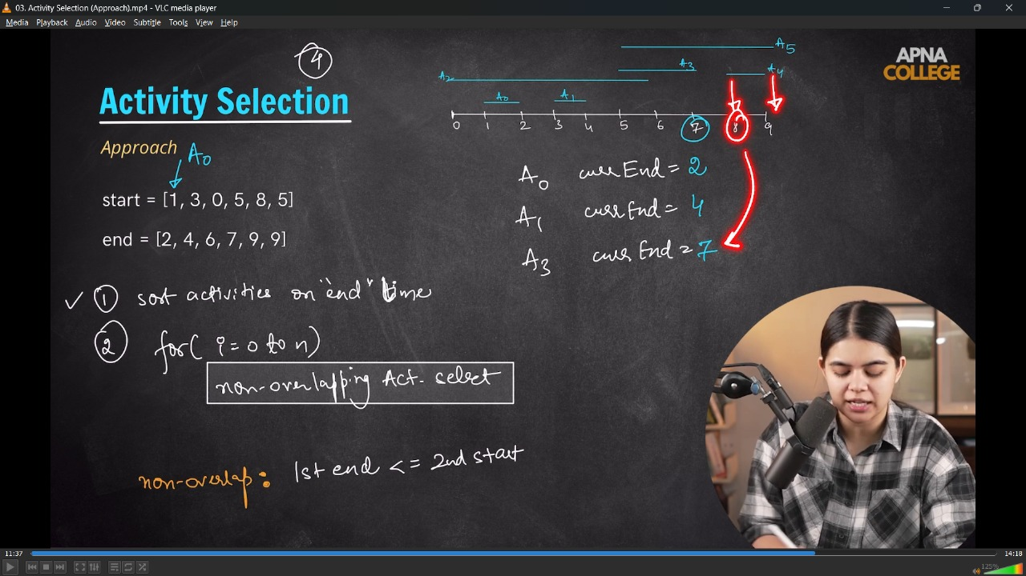
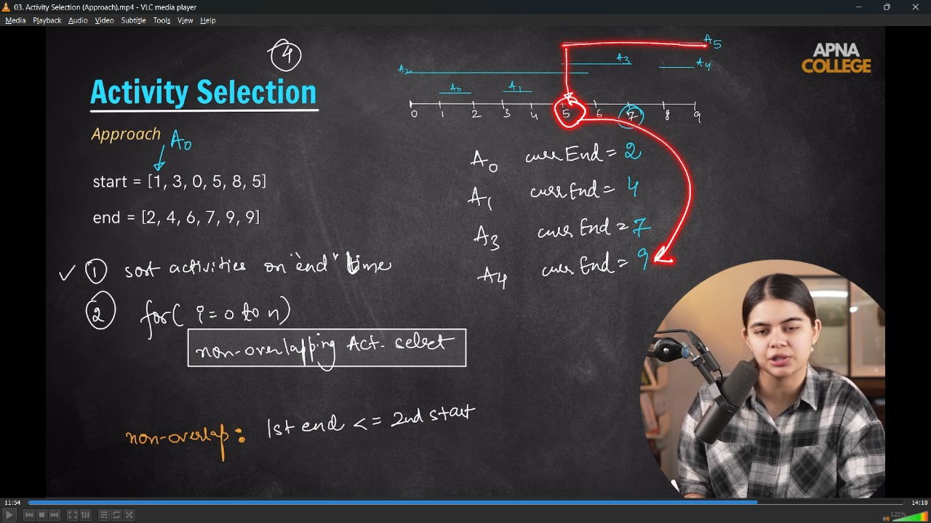
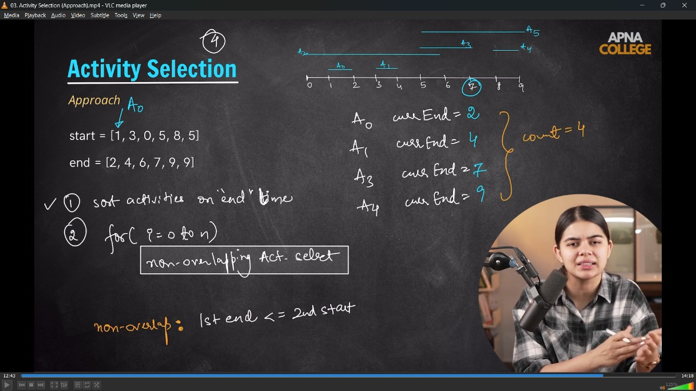
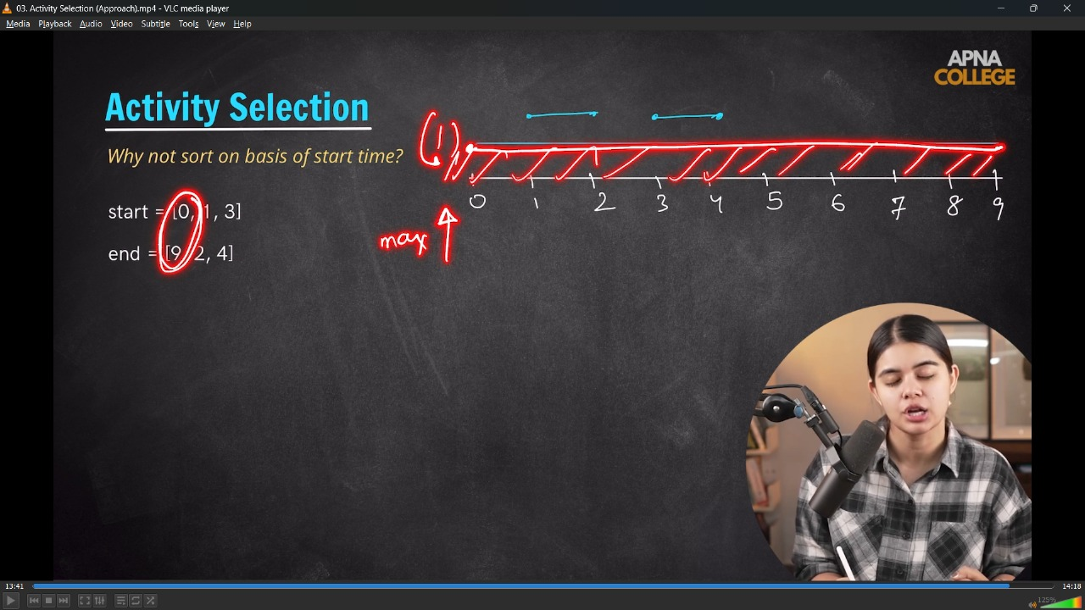
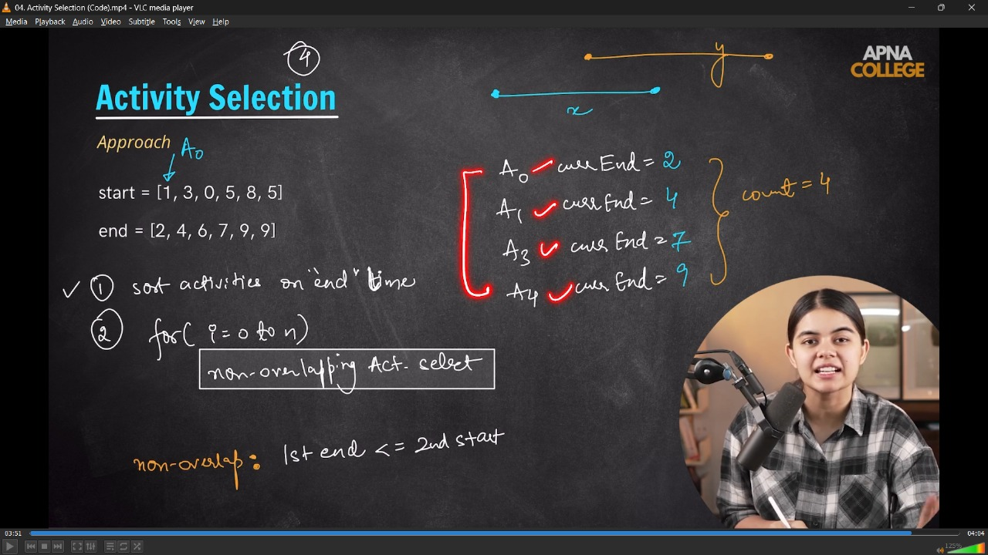
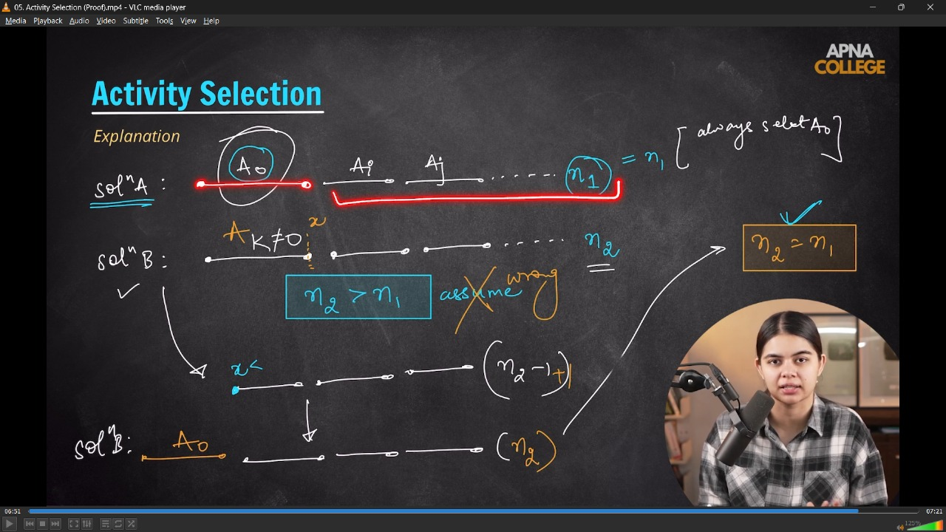
// // In the Activity Selection Problem - we can select a activity at a time. And if activities are overlapping then need to select only one.
// int maxActivities(vector<int> start, vector<int> end)
// {
// // If end time not givwn sorted then first sort the end time, then start t oappraoch
// // A0 selection as first least end tym
// int count = 1;
// cout << "Selecting A0" << endl;
// int currEndTime = end[0];

// for (int i = 0; i < start.size(); i++)
// {
// if (start[i] >= currEndTime) // selction of Non-Oerlapping Actitvity using end condition of respective activity by comparing with updated End activity timing
// {
// cout << "Selecting A" << i << endl;
// count++;
// currEndTime = end[i];
// }
// }

// return count;
// };
// int main()
// {
// vector<int> start = {1, 3, 0, 5, 8, 5};
// vector<int> end = {2, 4, 6, 7, 9, 9};
// cout << "So, the maximum Actitvites which can be perfomed are - " << endl;
// cout << maxActivities(start, end) << endl;

// /*
// So, the maximum Actitvites which can be perfomed are -
// Selecting A0
// Selecting A1
// Selecting A3
// Selecting A4
// 4

// */
// }
// ____________ ____________ ____________ ____________ ____________

// 2) Pair in C++ : STL container to store 2 objects –
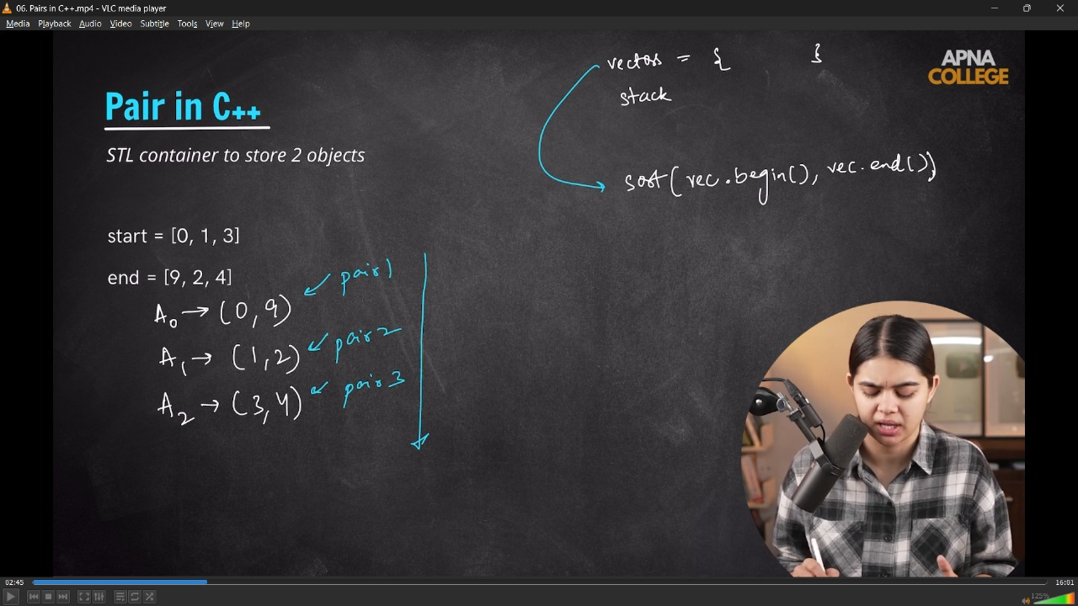
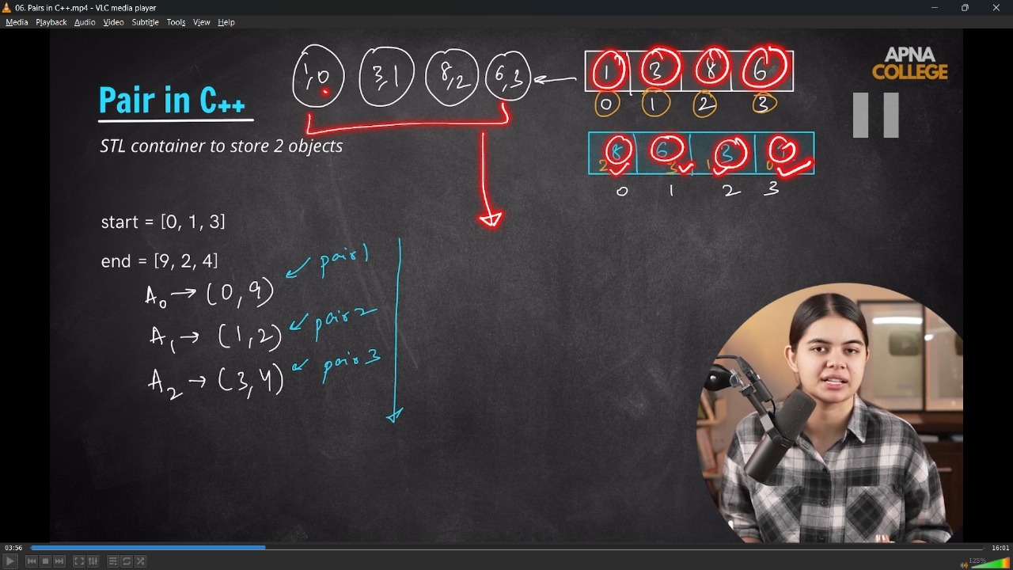

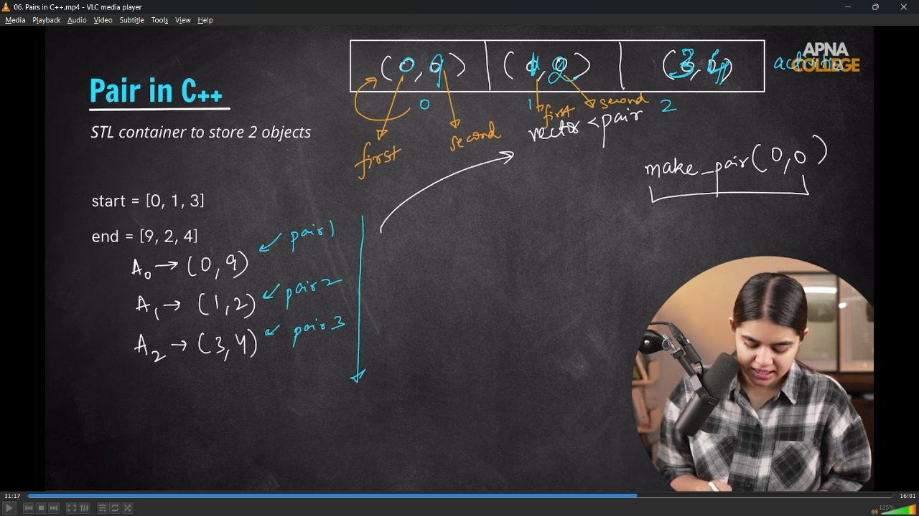
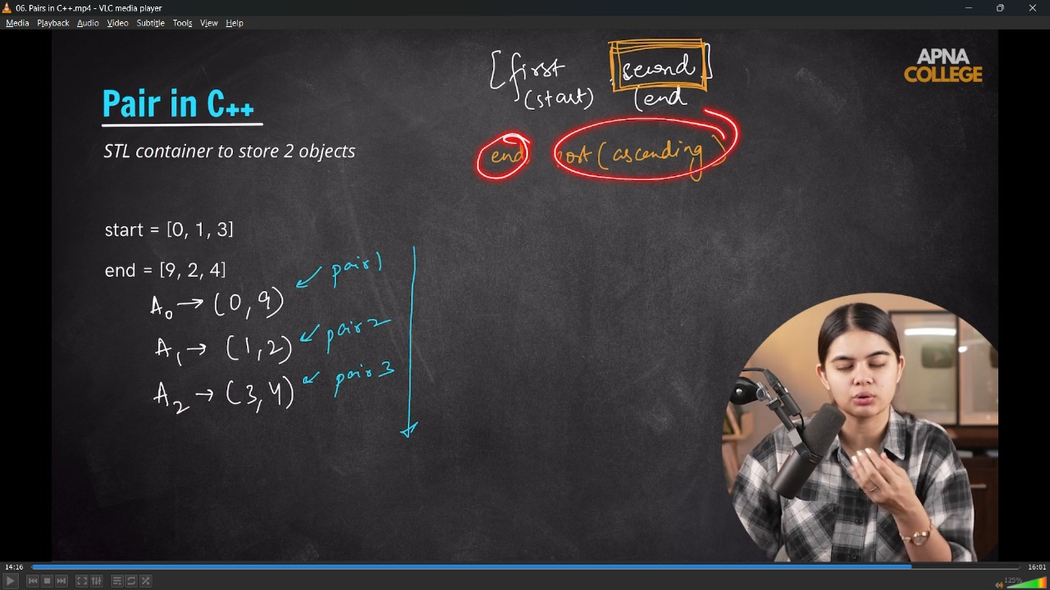
// /* in start & end container of both are unsorted then need to sort both , so using STL can be done both pairwise sorting
// As in vector we use int datatype, similarly by using vector with pair we can store differetn differertn datatypes

// Syntax of Pair -
// ➖ vector<pair<DATATYPE1><DATATYPE2>NAMEOFPAIR(sizeofpair, make_pair(0,0)) - created a size of pair with 0,0
// Cam also create manually by making pairs -
// ➖ vector<pair<int><int>ActivityPair(3, make_pair(0,0)) - 3 pairs of 0,0 has been created
// */
// bool comparision1(pair<int, int> p1, pair<int, int> p2)
// // In comparision we can perform any of the function while Asceding of firsr OR Descending of first OR Ascending of Second OR Descending of Second
// {
// return p1.second < p2.second; // Ascending of End
// }
// bool comparision2(pair<int, int> p1, pair<int, int> p2)
// {
// return p1.second > p2.second; // Descending of End
// }
// bool comparision3(pair<int, int> p1, pair<int, int> p2)
// {
// return p1.first < p2.first; // Ascending of Start
// }
// bool comparision4(pair<int, int> p1, pair<int, int> p2)
// {
// return p1.first > p2.first; // Descending of Start
// }

// int main()
// {

// vector<int> start = {0, 1, 2};
// vector<int> end = {9, 2, 4};

// vector<pair<int, int>> activity(3, make_pair(0, 0));
// activity[0] = make_pair(0, 9);
// activity[1] = make_pair(1, 2);
// activity[2] = make_pair(2, 4);

// cout << "So, the create pair are - " << endl;
// for (int i = 0; i < activity.size(); i++)
// {
// cout << "A" << i << " : " << activity[i].first << "," << activity[i].second << endl;
// }
// /*
// So, the create pair are -
// A0 : 0,9
// A1 : 1,2
// A2 : 2,4
// */

// // For sort the pairs -
// sort(activity.begin(), activity.end(), comparision1); // sorting using comparision1 function

// cout << "After Sorting when second increasing OR End TIme Ascending _________" << endl;

// cout << "So, the create pair are - " << endl;
// for (int i = 0; i < activity.size(); i++)
// {
// cout << "A" << i << " : " << activity[i].first << "," << activity[i].second << endl;
// }

// /*

// So, the create pair are -
// A0 : 0,9
// A1 : 1,2
// A2 : 2,4
// After Sorting when second increasing OR End TIme Ascending _________
// So, the create pair are -
// A0 : 1,2
// A1 : 2,4
// A2 : 0,9

// */

// sort(activity.begin(), activity.end(), comparision2); // sorting using comparision2 function

// cout << "After Sorting when second decreasing OR End TIme Descending _________" << endl;

// cout << "So, the create pair are - " << endl;
// for (int i = 0; i < activity.size(); i++)
// {
// cout << "A" << i << " : " << activity[i].first << "," << activity[i].second << endl;
// }

// /*

// So, the create pair are -
// A0 : 0,9
// A1 : 1,2
// A2 : 2,4
// After Sorting when second decreasing OR End TIme Descending _________
// So, the create pair are -
// A0 : 0,9
// A1 : 2,4
// A2 : 1,2
// */

// sort(activity.begin(), activity.end(), comparision3); // sorting using comparision3 function

// cout << "After Sorting when first increasing OR End TIme Ascending _________" << endl;

// cout << "So, the create pair are - " << endl;
// for (int i = 0; i < activity.size(); i++)
// {
// cout << "A" << i << " : " << activity[i].first << "," << activity[i].second << endl;
// }
// /*

// So, the create pair are -
// A0 : 0,9
// A1 : 1,2
// A2 : 2,4
// After Sorting when first increasing OR End TIme Ascending _________
// So, the create pair are -
// A0 : 0,9
// A1 : 1,2
// A2 : 2,4
// */

// sort(activity.begin(), activity.end(), comparision4); // sorting using comparision4 function

// cout << "After Sorting when first decreSING OR End TIme Descending _________" << endl;

// cout << "So, the create pair are - " << endl;
// for (int i = 0; i < activity.size(); i++)
// {
// cout << "A" << i << " : " << activity[i].first << "," << activity[i].second << endl;
// }
// /*

// So, the create pair are -
// A0 : 0,9
// A1 : 1,2
// A2 : 2,4
// After Sorting when first decreSING OR End TIme Descending _________
// So, the create pair are -
// A0 : 2,4
// A1 : 1,2
// A2 : 0,9
// */
// }
// ____________ ____________ ____________ ____________ ____________
3) Fractional Knapsack Problem -
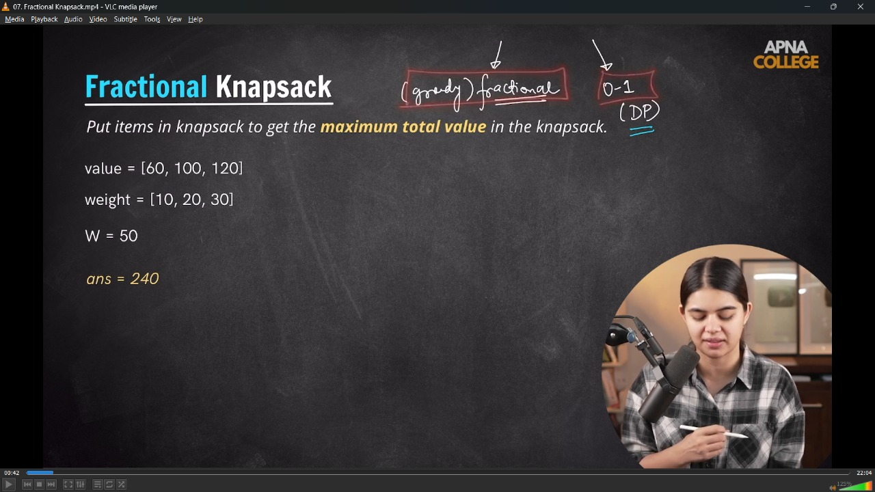
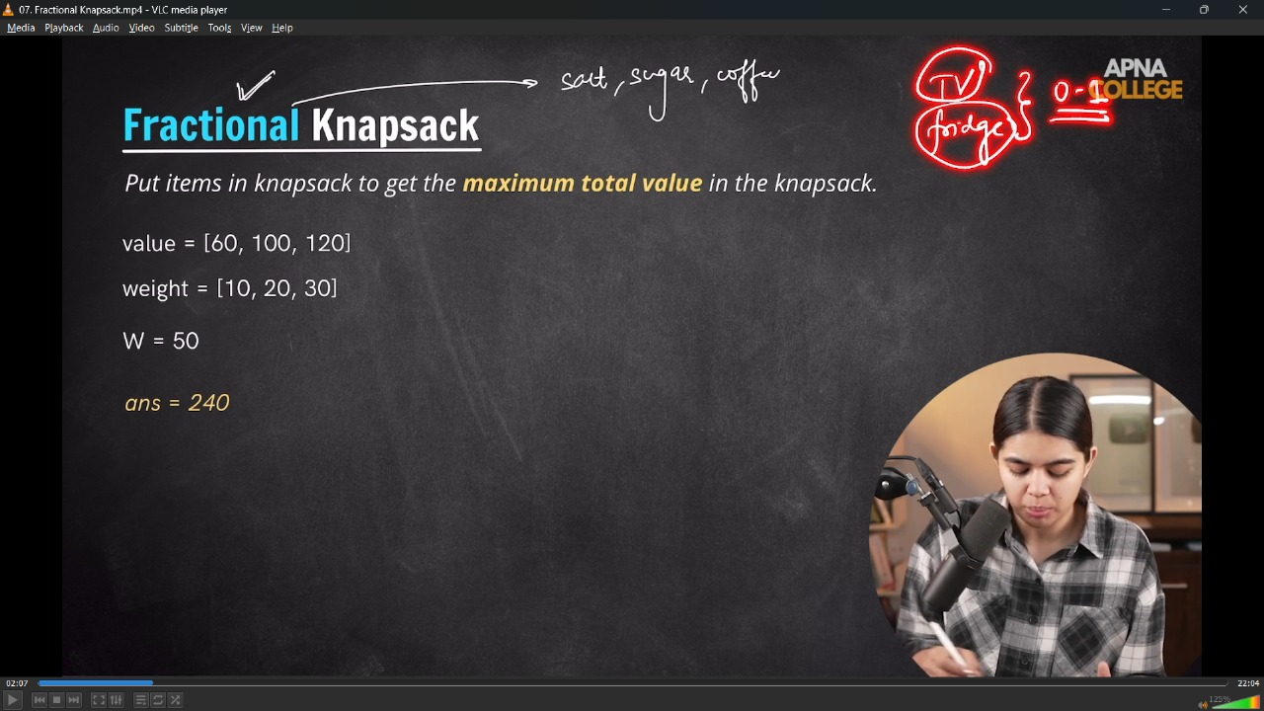
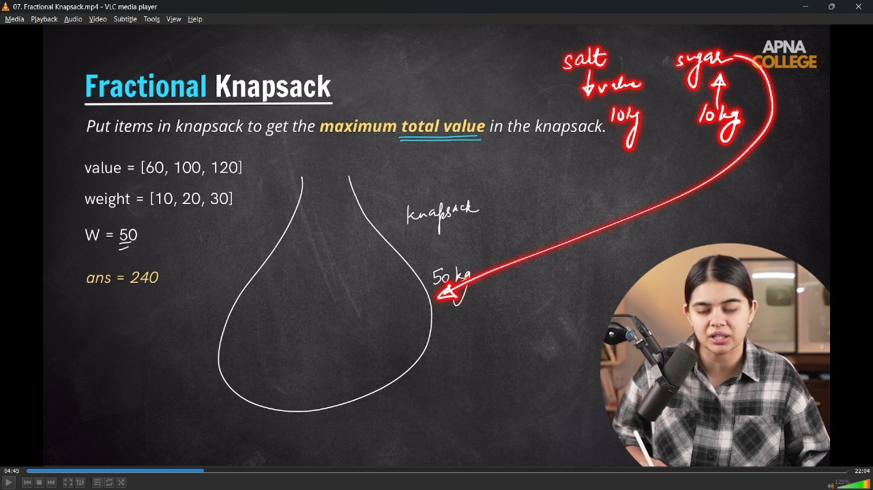
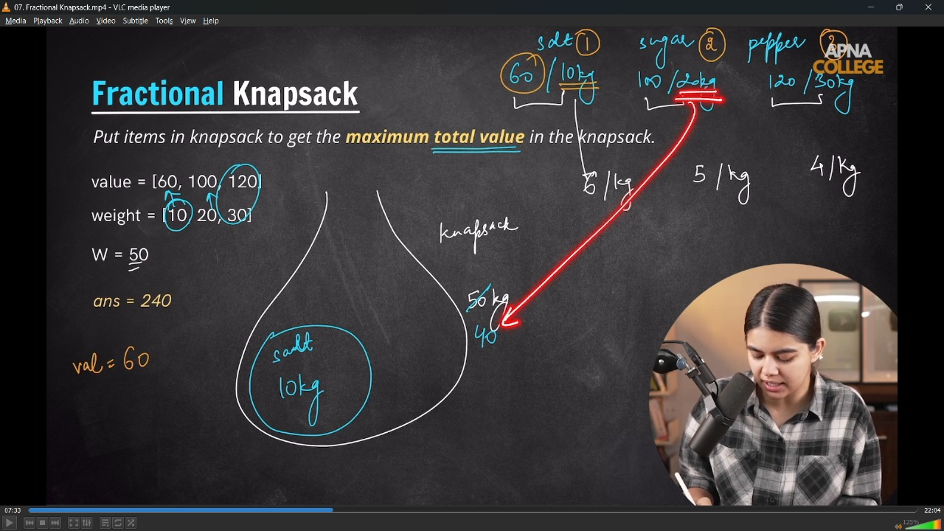
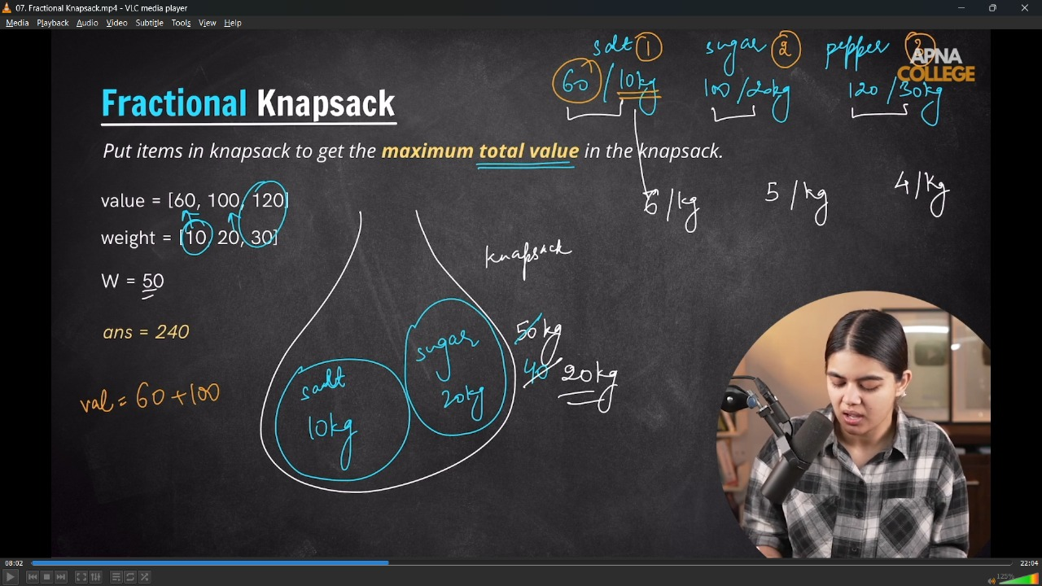
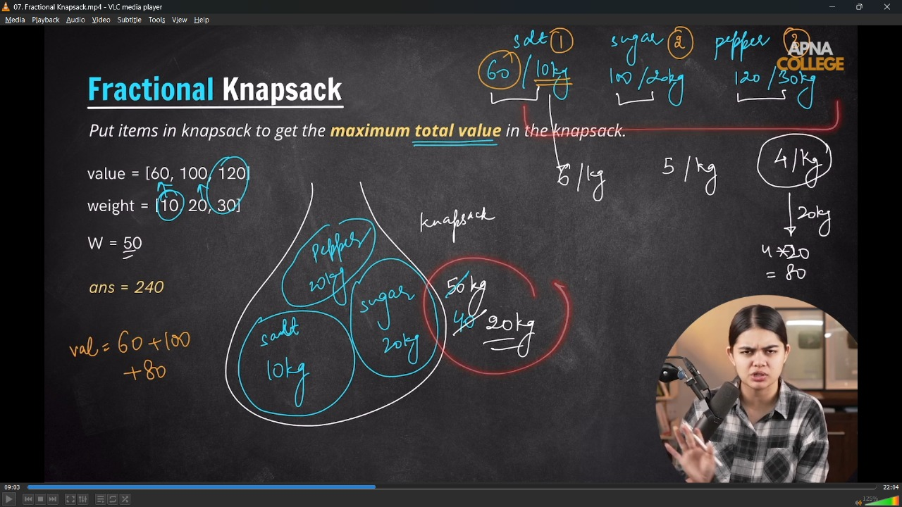
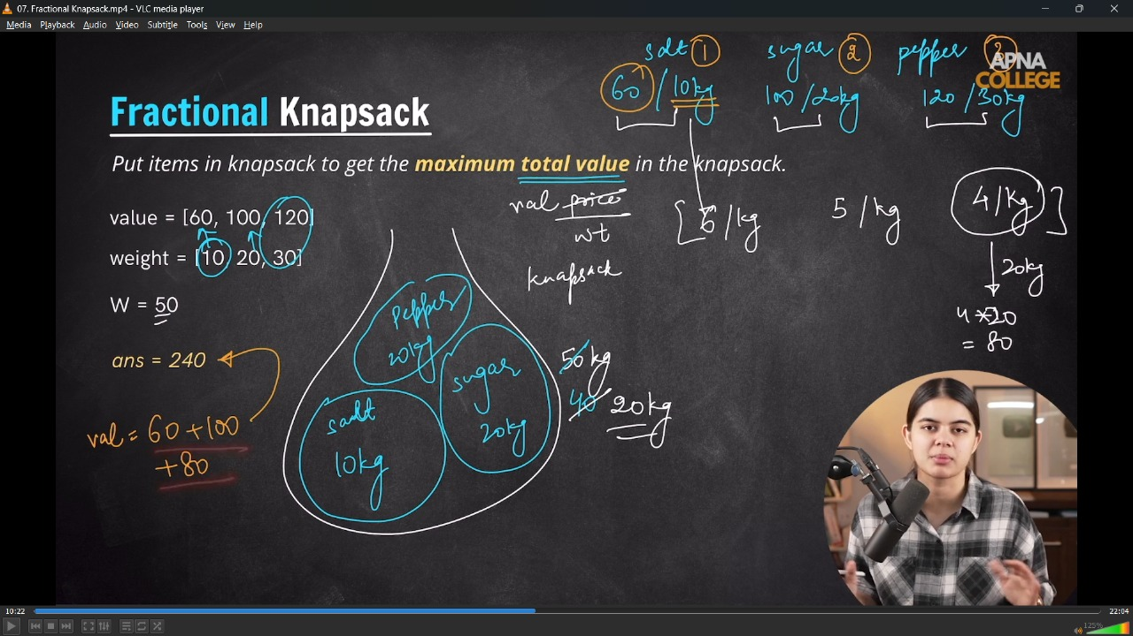
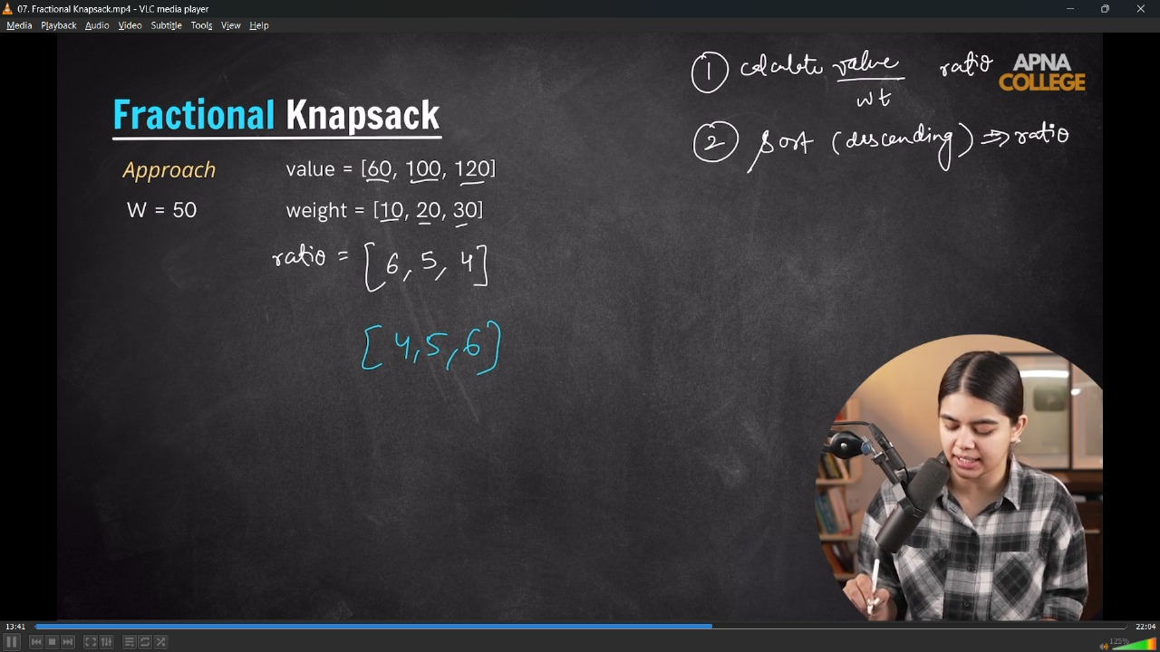
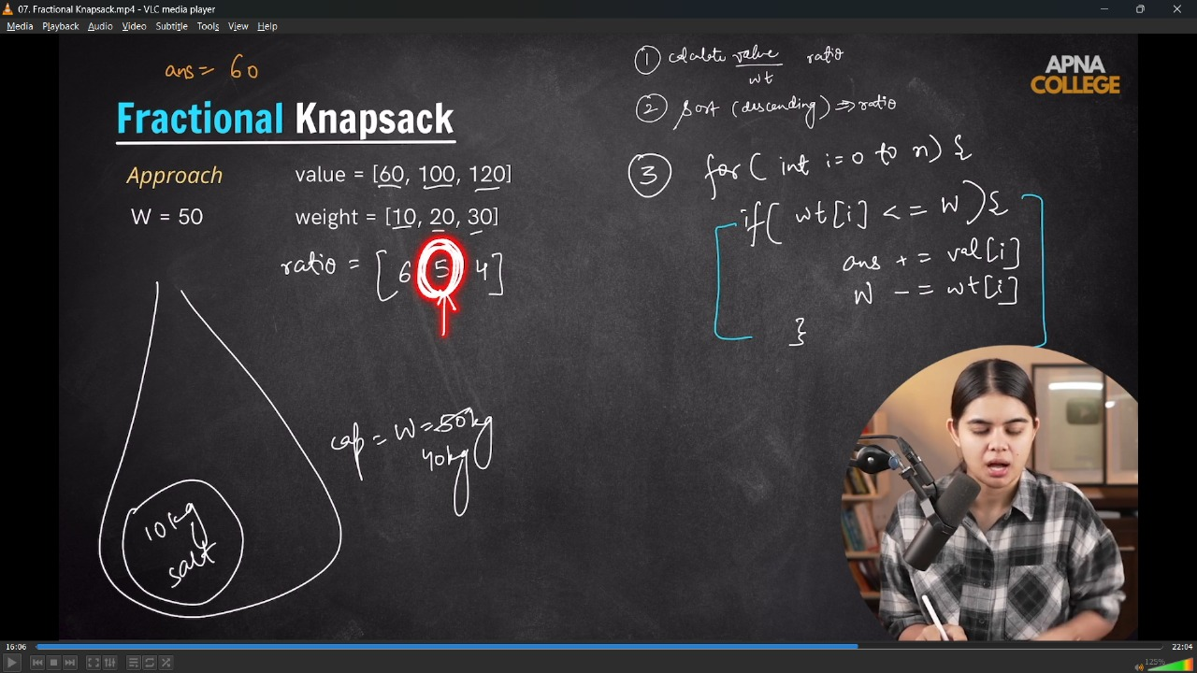
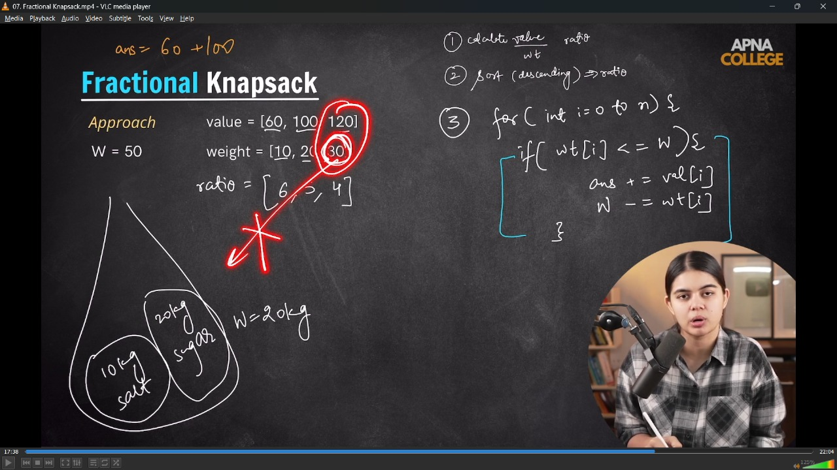
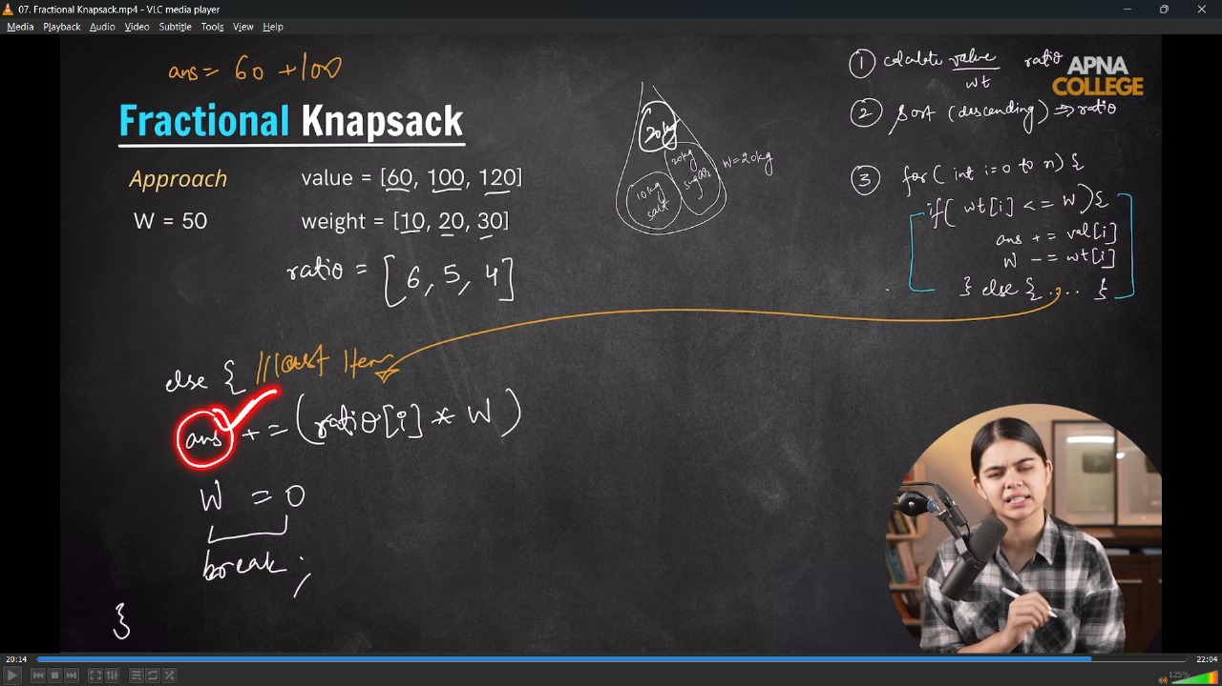
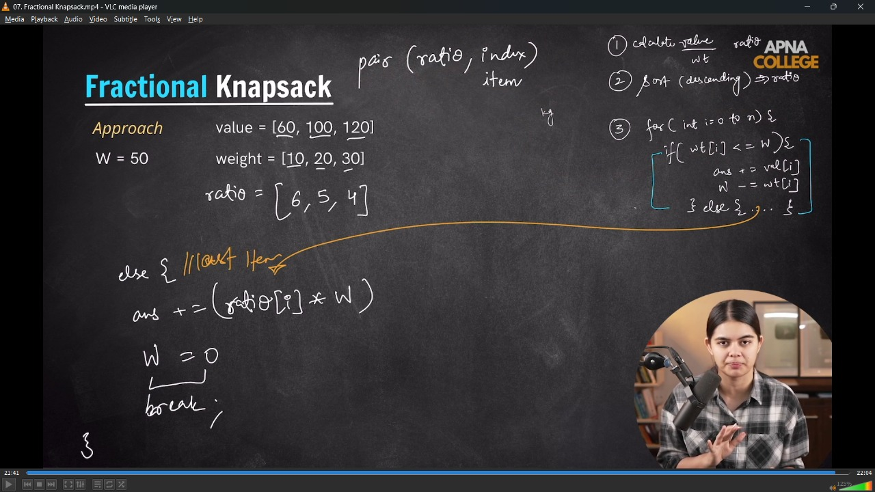
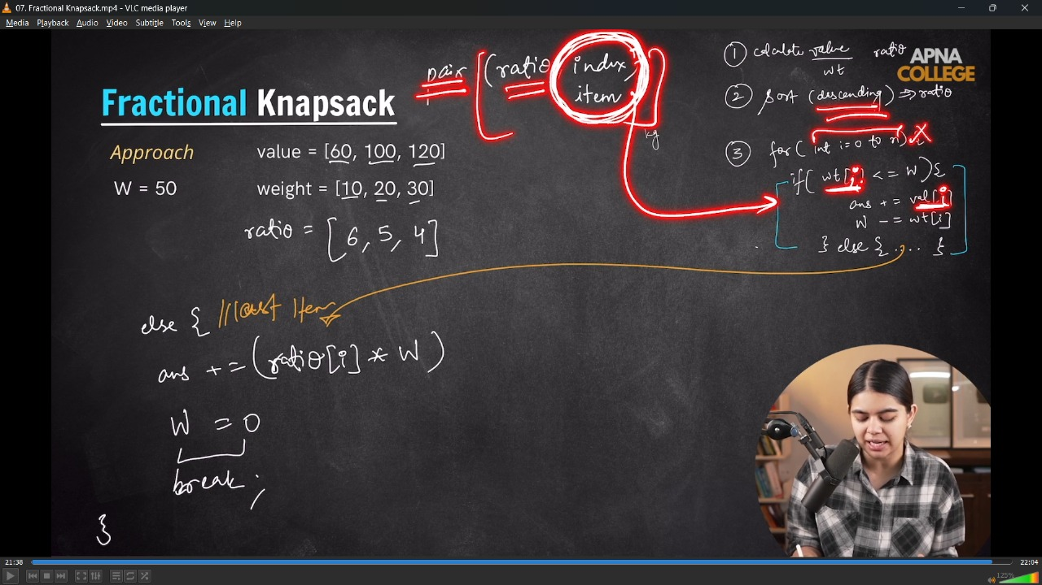
// /*
// 1.1 - Generally Jaha Quns me Maximum/minimum use ho rhe hote h and apart from Array, String(maxisum subarray, substring,subsequence,maxsu,minsum)
// then most probably chances for the application of => Greedy Algo's.
// 1.2 - Jaha ya to lenge ya phr nahi lenge - we use => 0-1 Knapsak Problem. [TV,Freze,Washing Machine]
// but jaha quantitymatter kr jati he [halfkg, 1 kg, 5 kg - suga,salt,oil] which can be inside Kanpsack(Bora,thela) then we use => Fractioal Kapsack Problem.

// 1.3 - Greedy algo - yahi kahti he ki for gtting the Global Max need to choose local max - so that we can get the optimixed global max
// */

// bool compare(pair<double, int> p1, pair<double, int> p2)
// {
// return p1.first > p2.first; // descending values based on ratio
// }

// int fractionalKnapsackProblem(vector<int> val, vector<int> wt, int w)
// {
// int n = val.size();
// vector<pair<double, int>> ratio(n, make_pair(0.0, 0)); // pair of (ratio, idx) -> (double,int)

// for (int i = 0; i < n; i++)
// {
// double r = val[i] / (double)wt[i];
// ratio[i] = make_pair(r, i);
// }

// sort(ratio.begin(), ratio.end(), compare);
// int ans = 0;
// for (int i = 0; i < n; i++)
// {
// int idx = ratio[i].second; // wt,val
// if (wt[idx] <= w)
// {
// ans += val[idx];
// w -= wt[idx];
// }
// else
// {
// ans += ratio[i].first * w;
// w = 0;
// break;
// }
// }

// cout << "Max Value - " << ans << endl;
// return ans;
// }

// int main()
// {
// vector<int> val = {60, 100, 120};
// vector<int> wt = {10, 20, 30};
// int w = 50;

// fractionalKnapsackProblem(val, wt, w);
// return 0;
// /*
// Max Value - 240
// TC - O(n+nlogn+n) = O(nlogn)
// */
// }
// ____________ ____________ ____________ ____________ ____________

4) Minimum Absolute DIfferent Pairs -
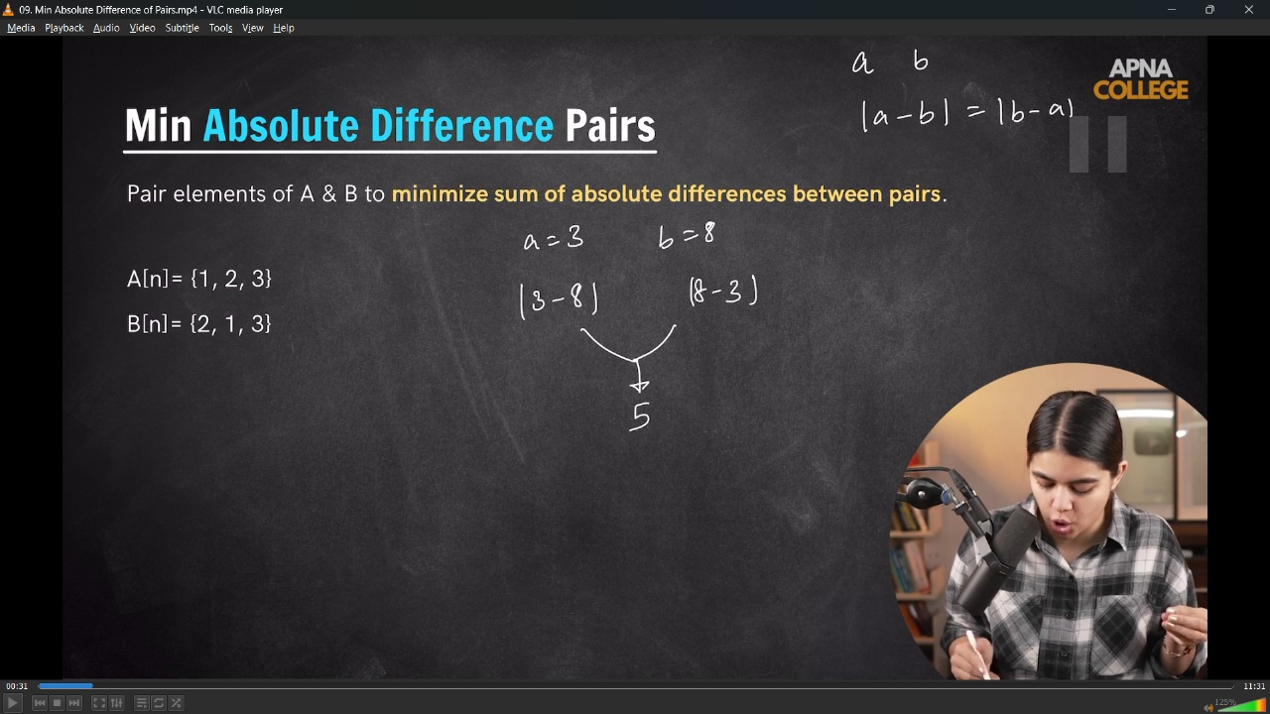
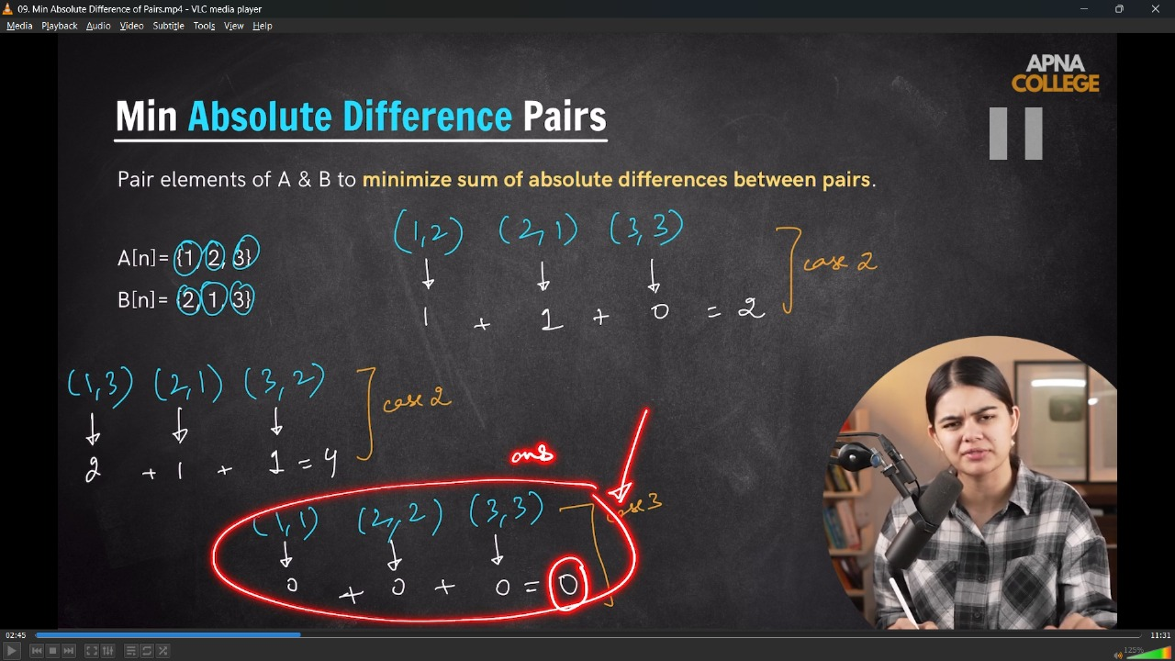
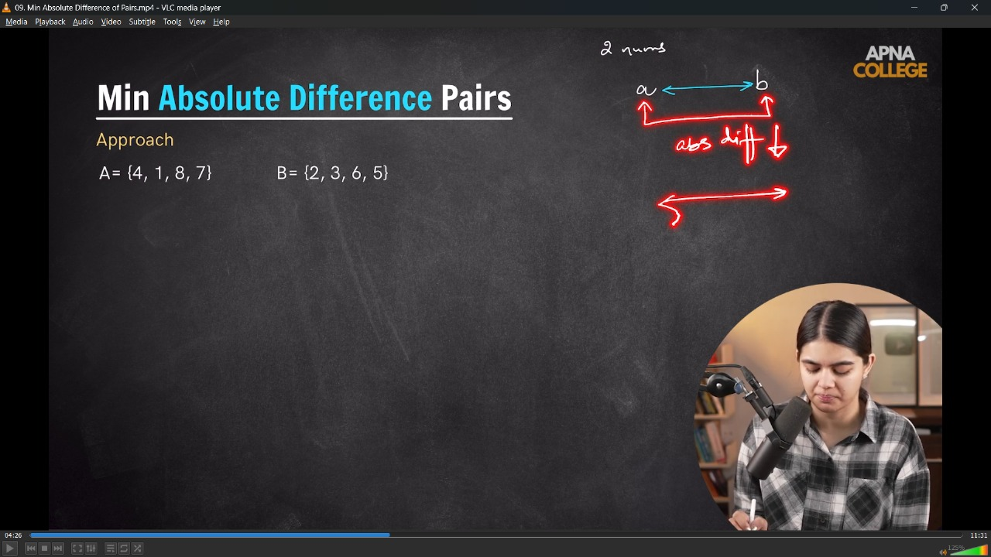
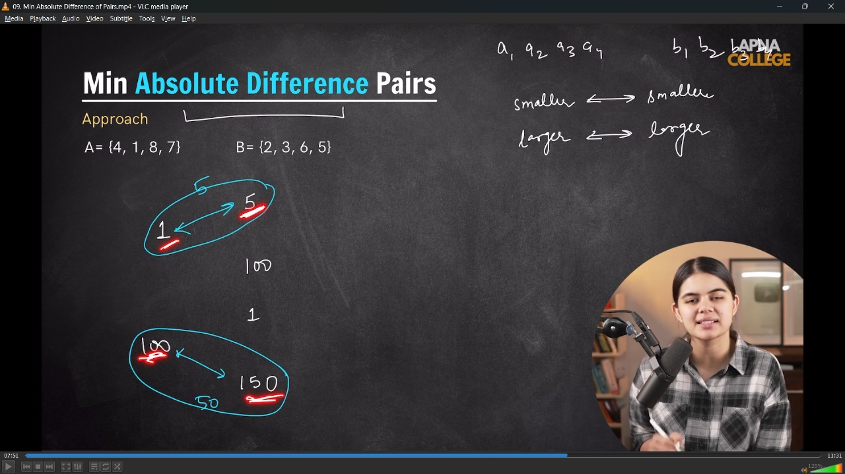
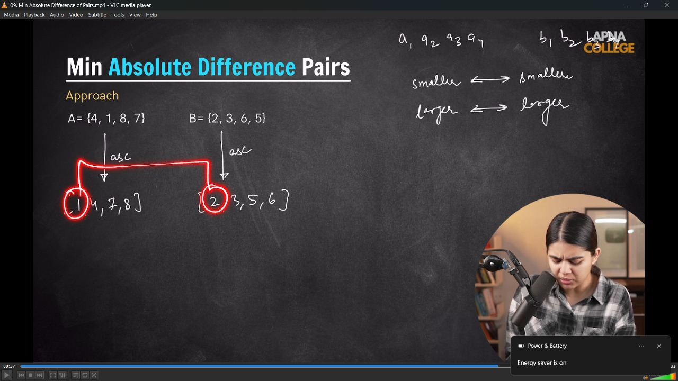
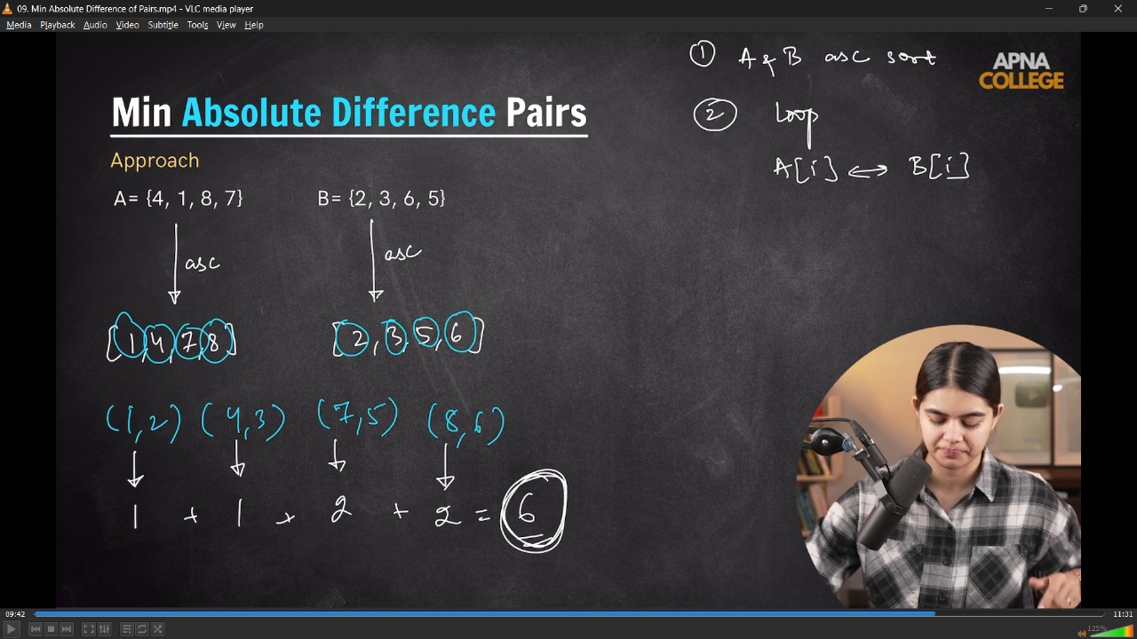
// /* For Minimum Absolute DOIfference between two same data structures is simply sort both and get the difference pairwise respectively
// */

// void absoluteDifference(vector<int> A, vector<int> B)
// {
// sort(A.begin(), A.end());
// sort(B.begin(), B.end());

// int absDiff = 0;

// for (int i = 0; i < A.size(); i++)
// {
// absDiff += abs(A[i] - B[i]);
// }

// cout << "Min Absolute Difference is - " << absDiff << endl;
// }

// int main()
// {
// /*
// vector<int> A = {4, 1, 8, 7};
// vector<int> B = {2, 3, 6, 5};

// absoluteDifference(A, B);
// /*
// Min Absolute Difference is - 6

// */

// vector<int> A = {1, 2, 3};
// vector<int> B = {3, 2, 1};

// absoluteDifference(A, B);
// /*
// Min Absolute Difference is - 0

// */

// return 0;
// }
// ____________ ____________ ____________ ____________ ____________

5) Maximum Chain Length of Pairs -
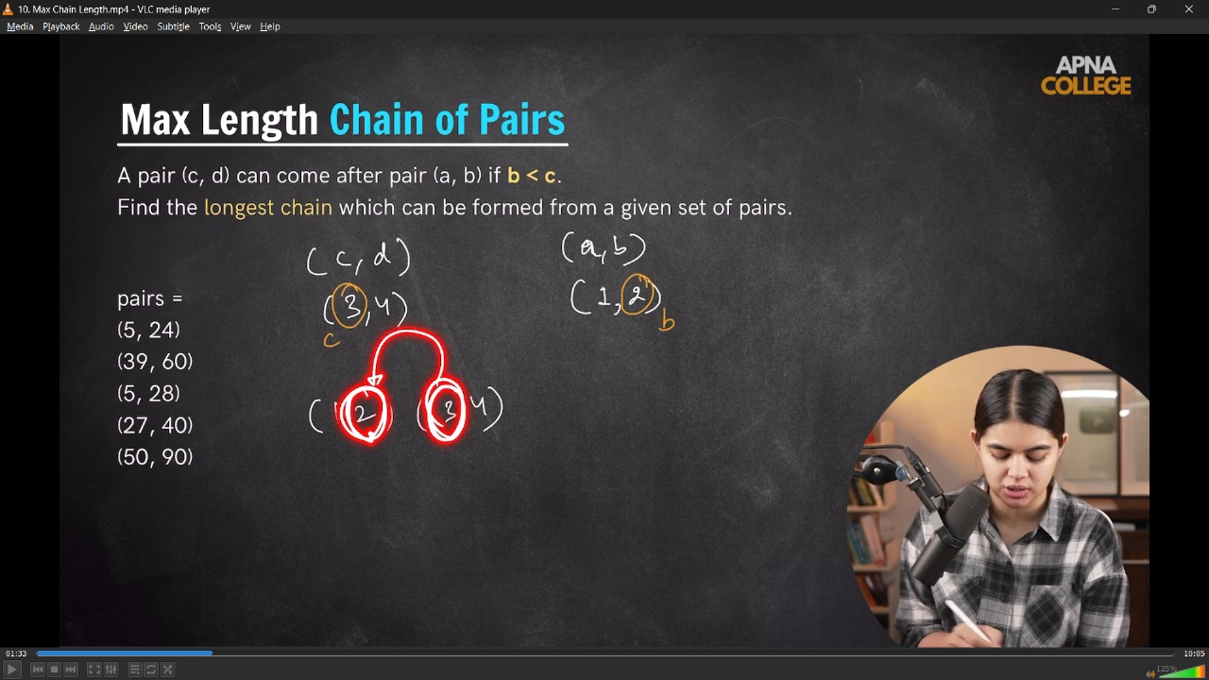
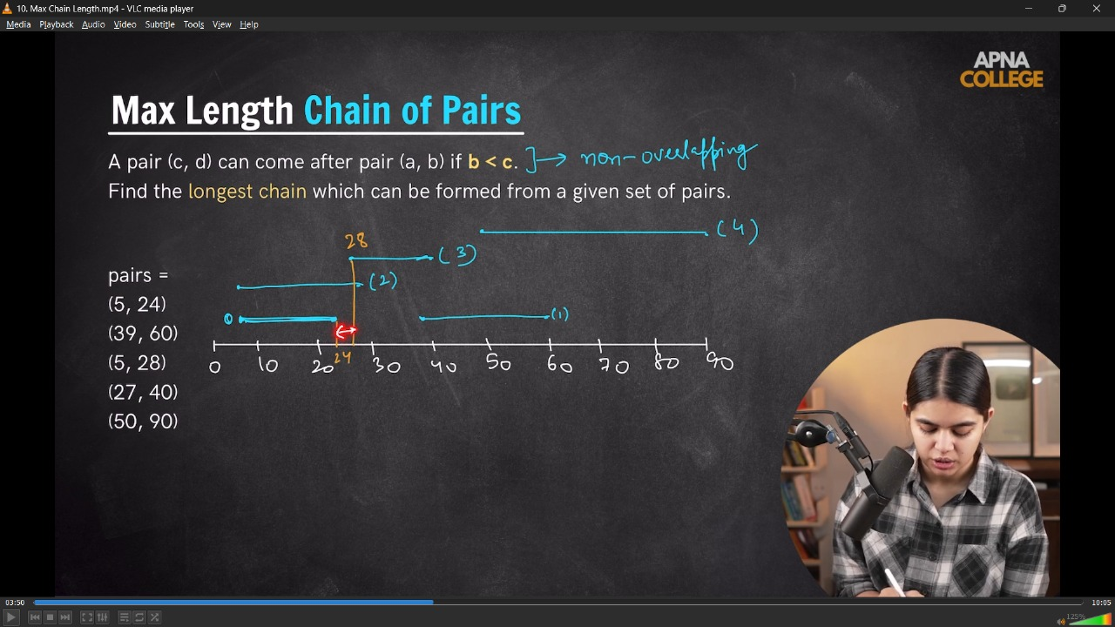
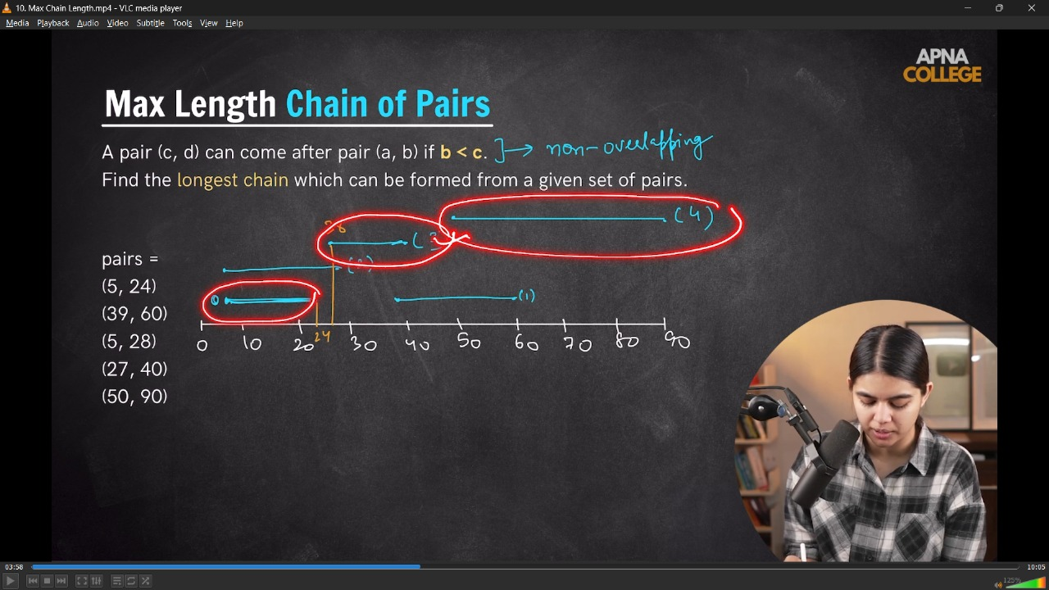
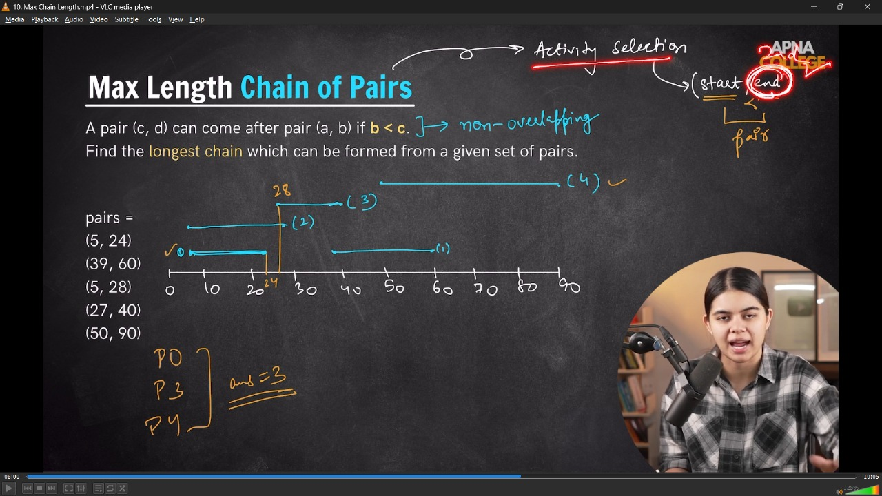
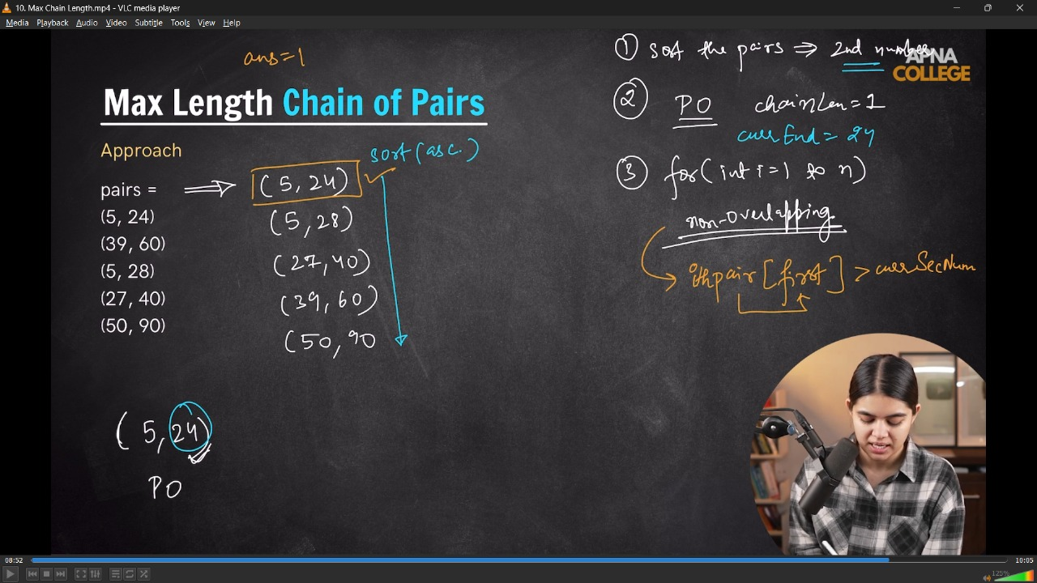
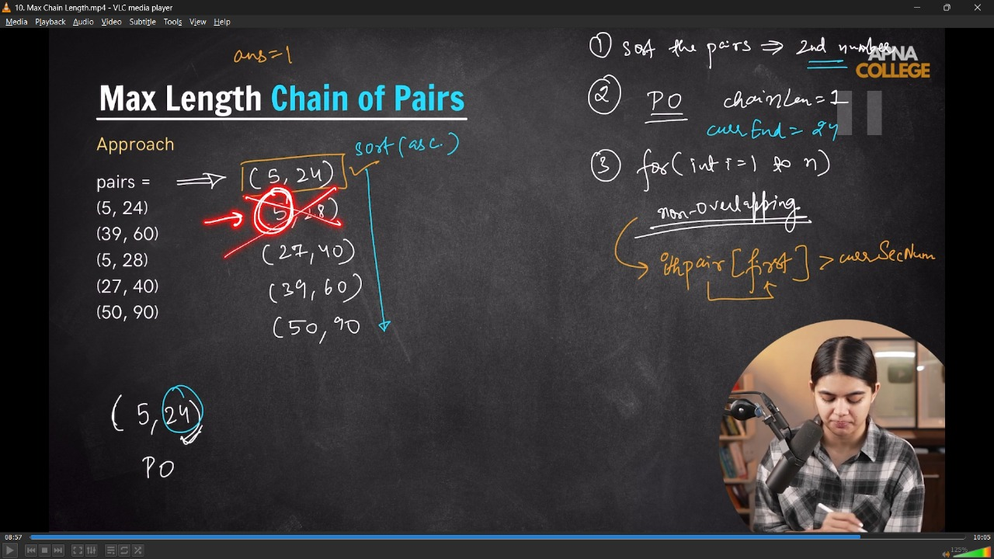
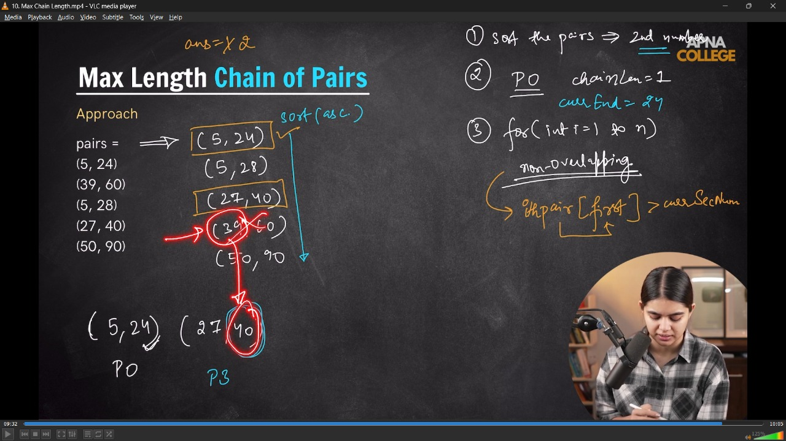
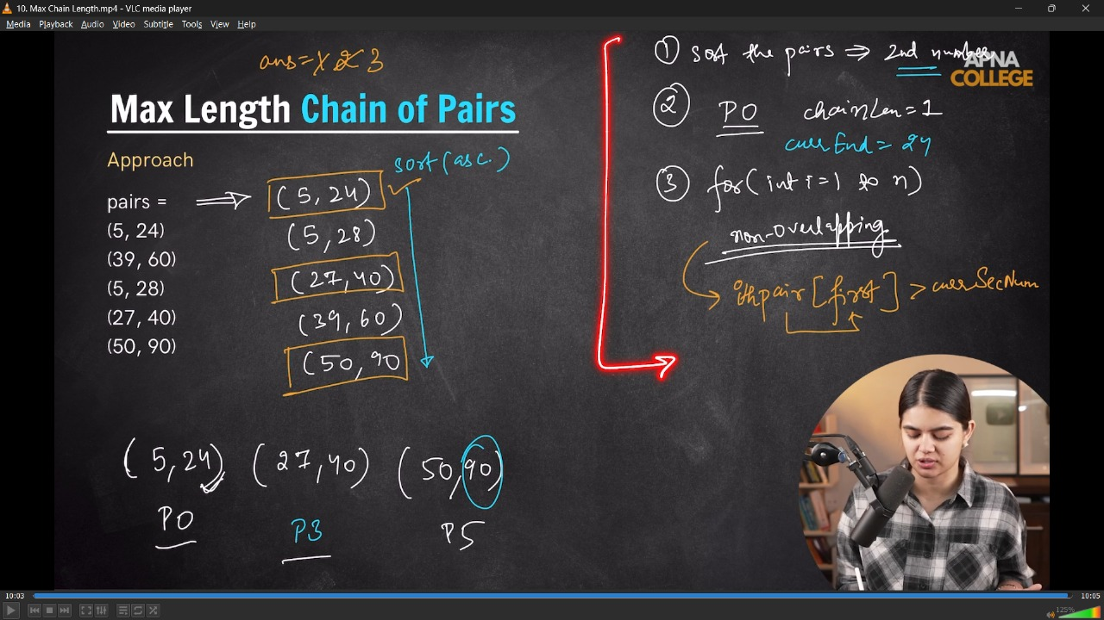
// /* In tjhs we are here sorting pair wise and comparing using second should be less than for another's first
// */
// bool compare(pair<int, int> p1, pair<int, int> p2)
// {
// return p1.second < p2.second; // ascending condition for element 2
// }

// int maxChainLength(vector<pair<int, int>> pairs)
// {
// int n = pairs.size();

// sort(pairs.begin(), pairs.end(), compare);
// int ans = 1;
// int currEnd = pairs[0].second;

// for (int i = 1; i < n; i++)
// {
// if (pairs[i].first > currEnd)
// {
// ans++;
// currEnd = pairs[i].second;
// }
// }

// cout << "maximum Chain Length = " << ans << endl;
// return ans;
// }

// int main()
// {
// int n = 5;
// vector<pair<int, int>> pairs(n, make_pair(0, 0));
// pairs[0] = make_pair(5, 24);
// pairs[1] = make_pair(39, 60);
// pairs[2] = make_pair(5, 28);
// pairs[3] = make_pair(27, 40);
// pairs[4] = make_pair(50, 90);

// maxChainLength(pairs);
// return 0;
// /*
// maximum Chain Length = 3
// */
// }
// ____________ ____________ ____________ ____________ ____________

6) Indian Coins Problem -
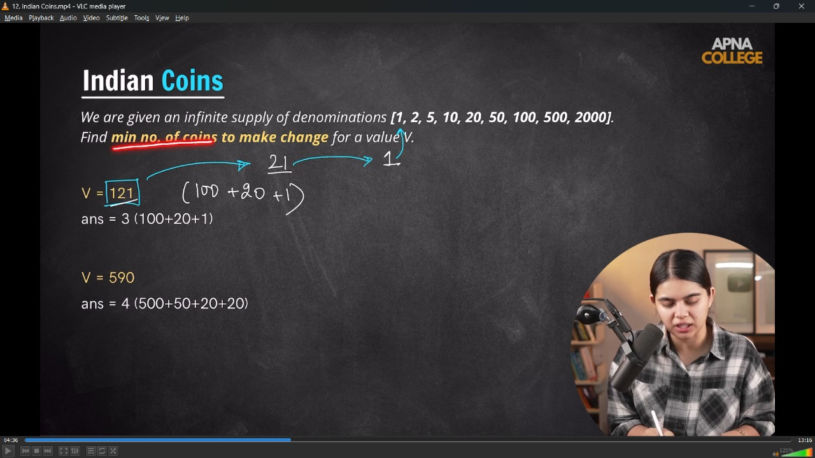
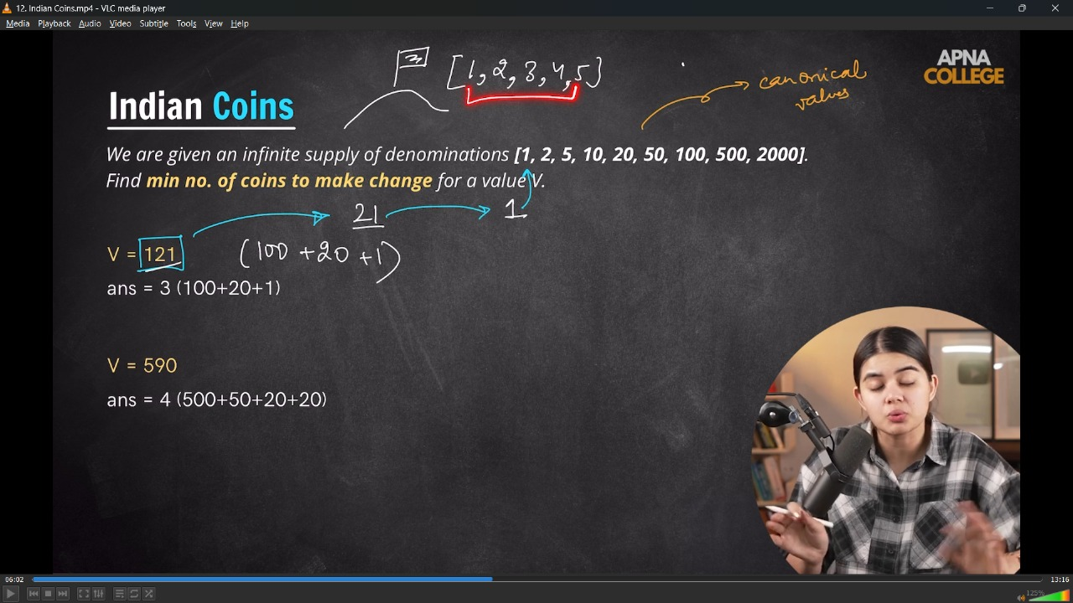
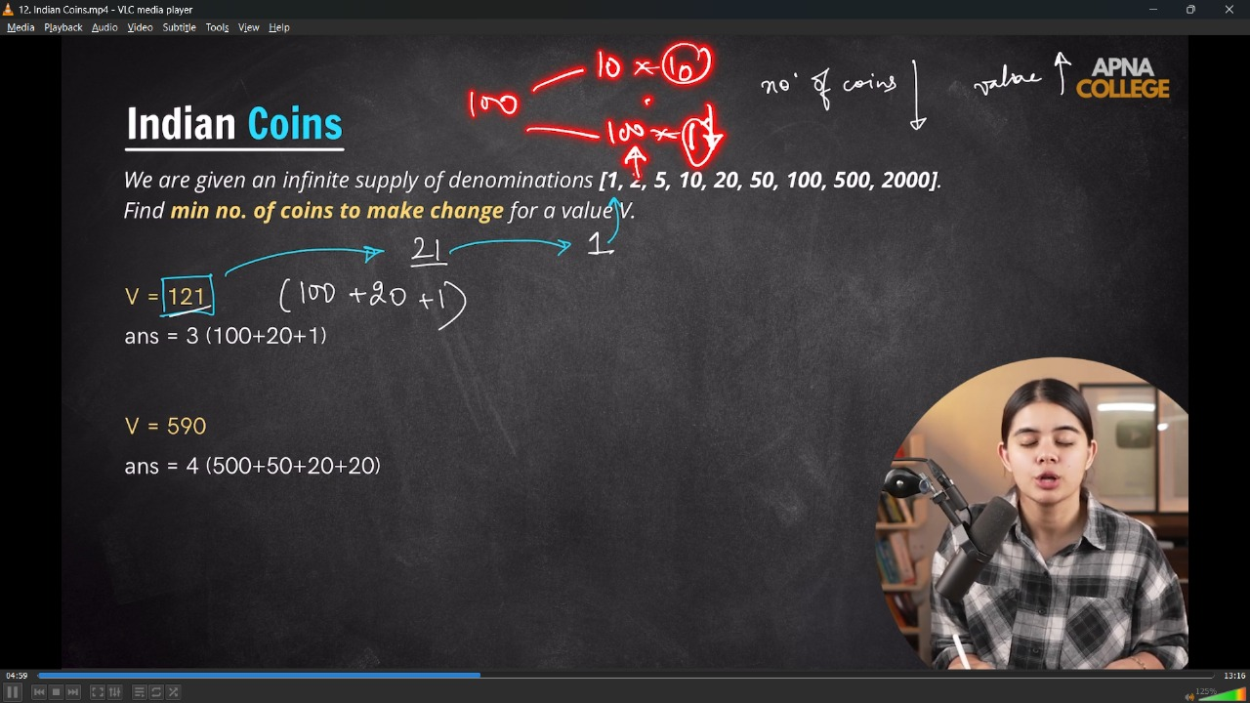
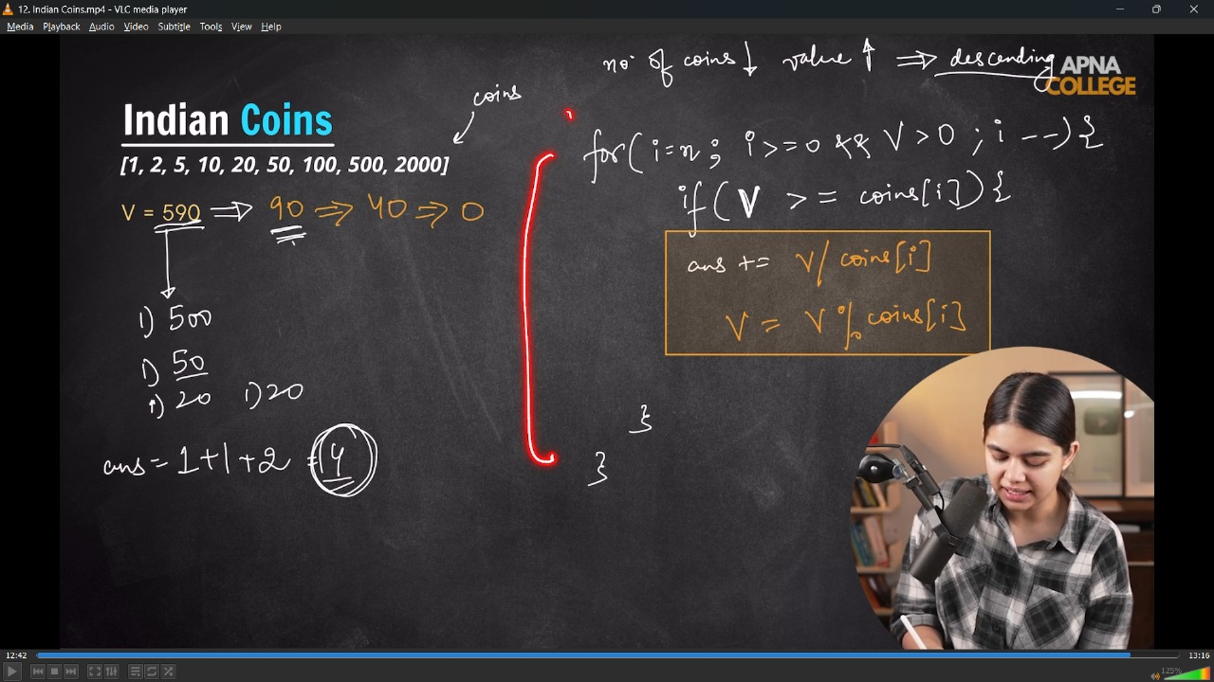
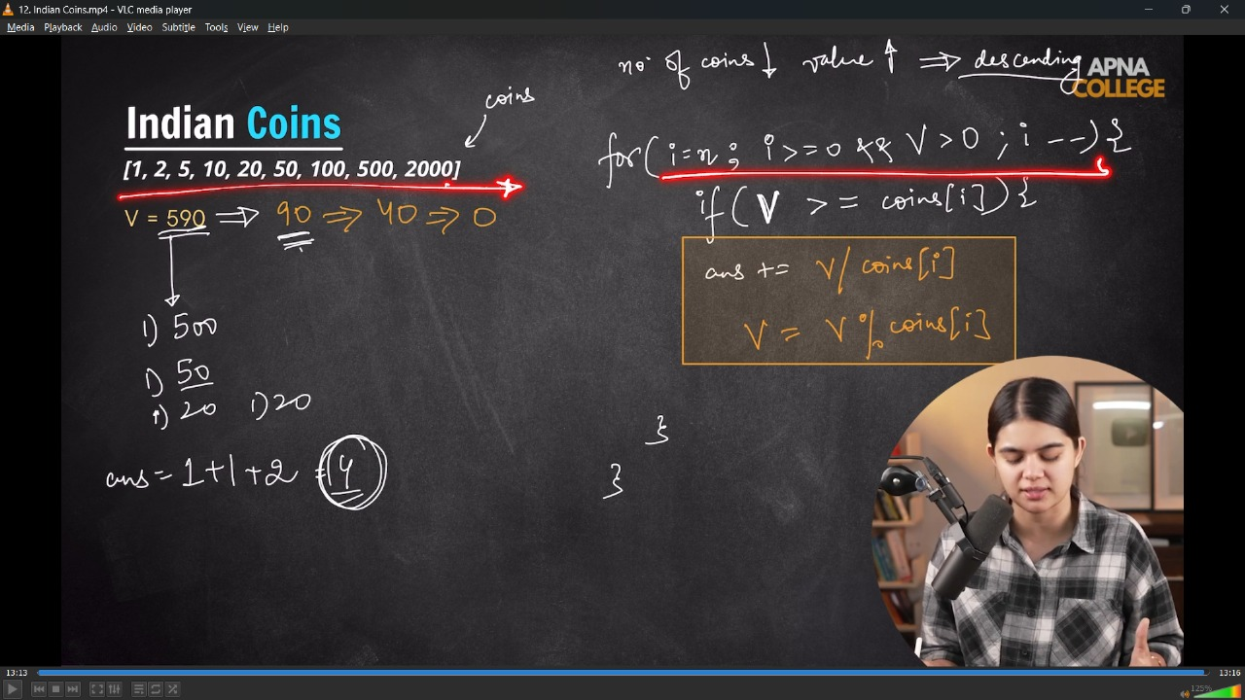
// int getMinChange(vector<int> coins, int v)
// {
// int ans = 0;
// int n = coins.size();

// for (int i = n - 1; i >= 0 && v > 0; i--)
// {
// if (v >= coins[i])
// {
// ans += v / coins[i];
// v = v % coins[i];
// }
// // cout << "Coins we are counting - " << coins[i] << endl;
// }
// cout << "Min coins for change for value is- " << ans << endl;
// return ans;
// }
// int main()
// {
// vector<int> coins = {1, 2, 5, 10, 20, 50, 100, 500, 2000};
// int v = 590; // value
// getMinChange(coins, v);
// getMinChange(coins, 121);
// getMinChange(coins, 1525);
// /*
// Min coins for change for value is- 4
// Min coins for change for value is- 3
// Min coins for change for value is- 5

// TC -O(N) - When already given in the sorted manner, but when need to sort then the compexity will be O(nlogn)
// */
// }
// ____________ ____________ ____________ ____________ ____________

7) Job Sequencing Problem –
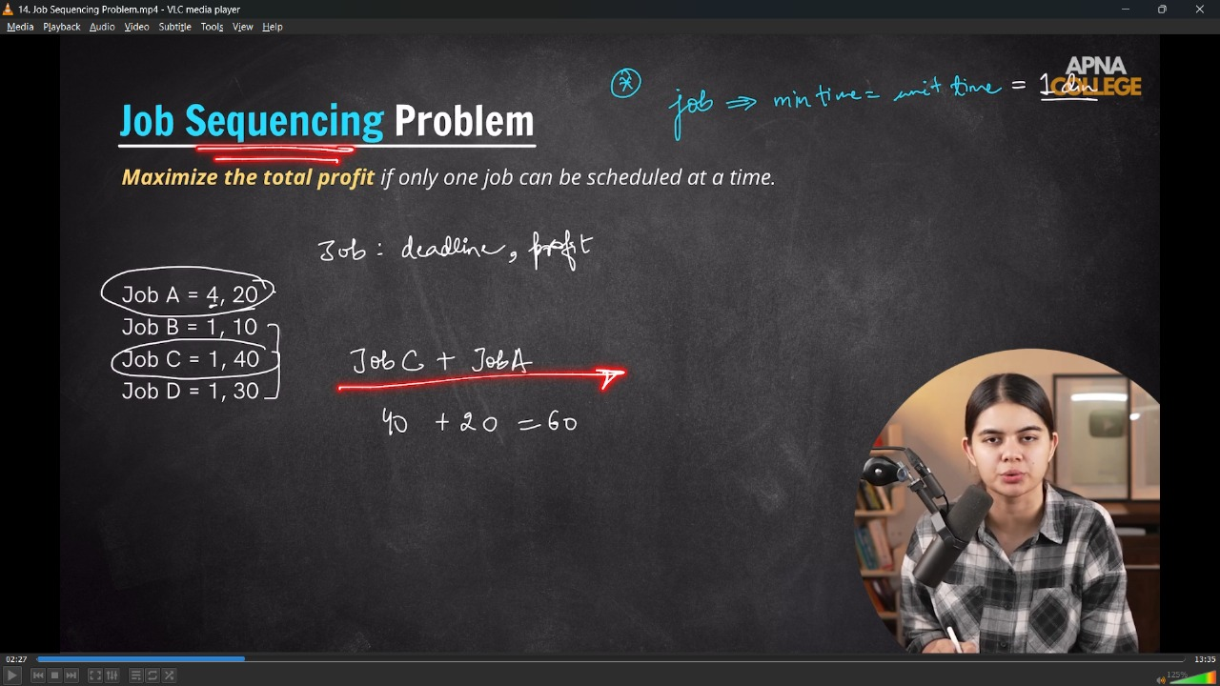
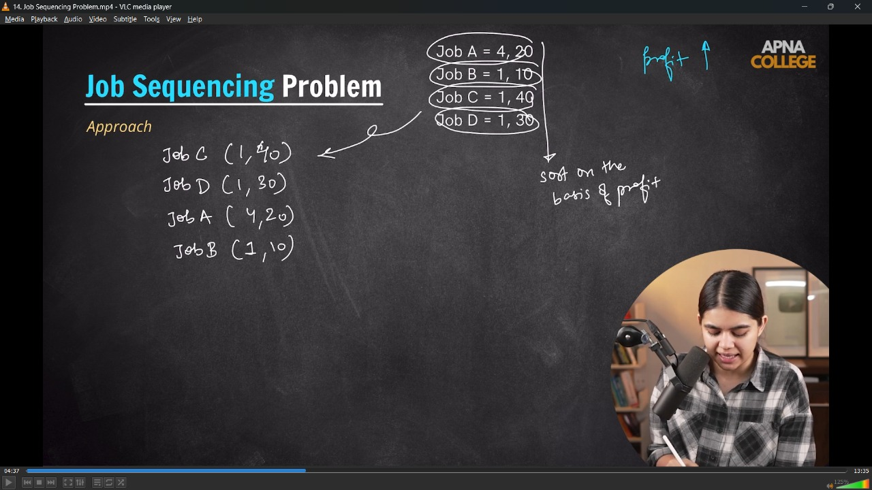
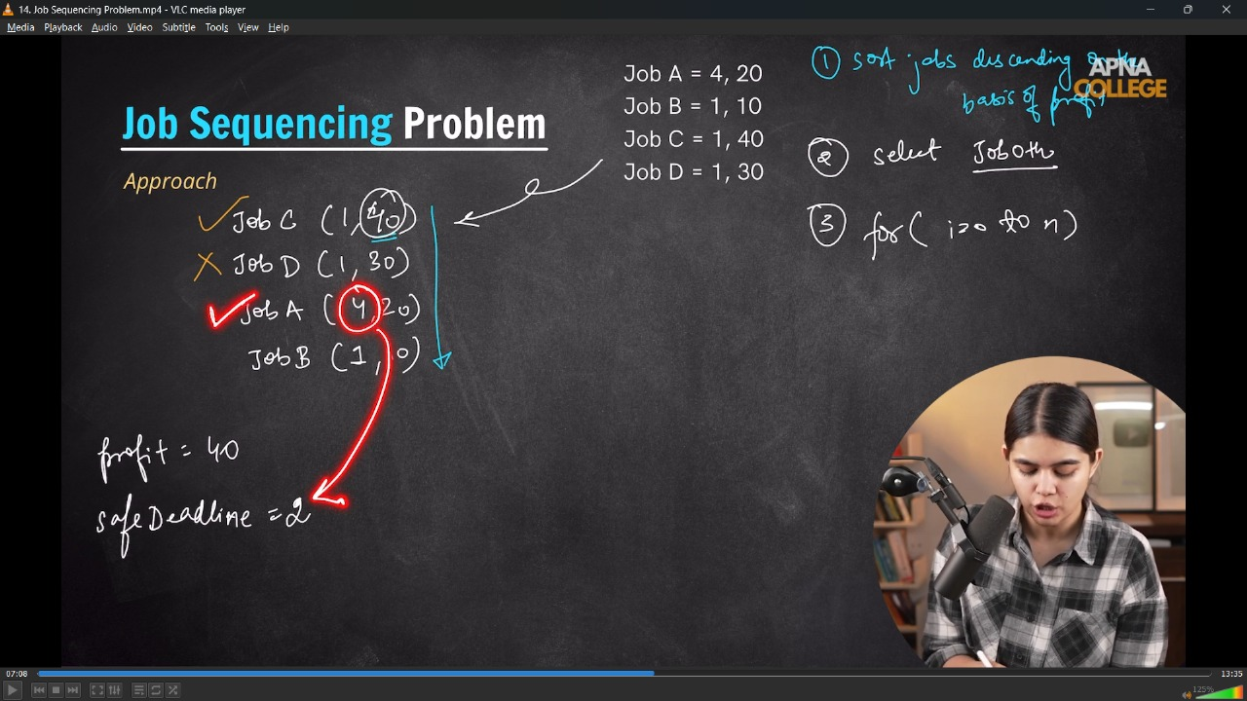
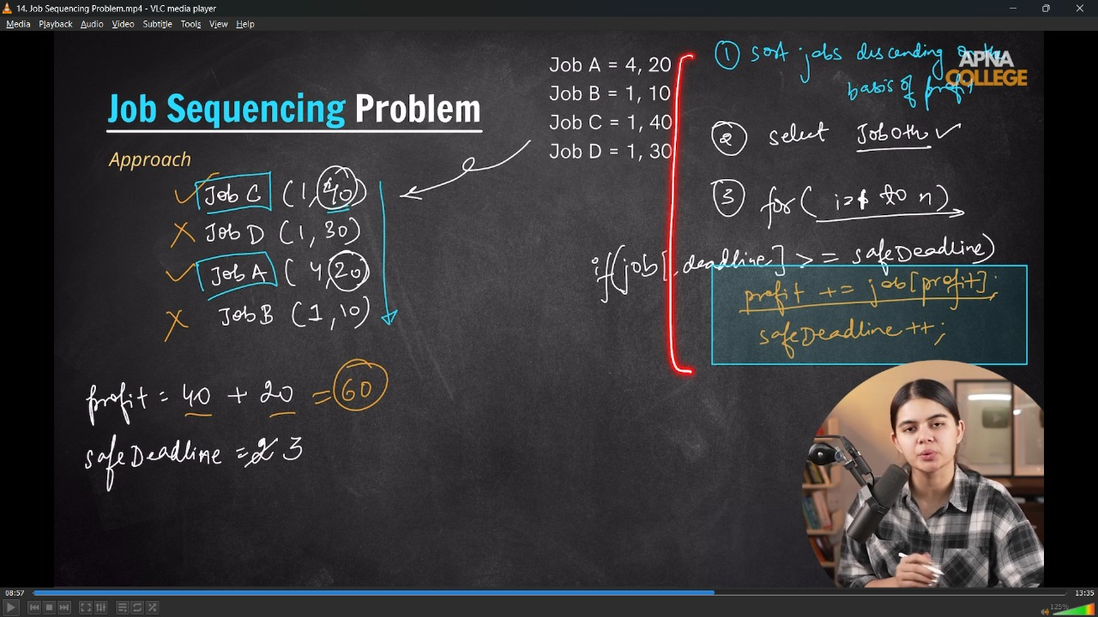
// bool compare(pair<int, int> p1, pair<int, int> p2)
// {
// return p1.second > p2.second;
// }

// int maxProfit(vector<pair<int, int>> jobs)
// {
// sort(jobs.begin(), jobs.end(), compare);
// // first -> deadline, second->profit

// int profit = jobs[0].second;
// int safeDeadline = 2;

// for (int i = 1; i < jobs.size(); i++)
// {
// if (jobs[i].first >= safeDeadline)
// {
// profit += jobs[i].second;
// safeDeadline++;
// }
// }
// cout << "max profit from jobs - " << profit << endl;
// return profit;
// }

// int main()
// {
// int n = 4;
// vector<pair<int, int>> jobs(n, make_pair(0, 0));
// jobs[0] = make_pair(4, 20);
// jobs[1] = make_pair(1, 10);
// jobs[2] = make_pair(1, 40);
// jobs[3] = make_pair(1, 30);

// maxProfit(jobs);
// return 0;
// /*
// max profit from jobs - 60

// */
// }

// ____________ ____________

// 7.1) Jonb Sequencing , print the multiple valies - which job , how much profit.
/*
In case when need to print the multipe values - current value, profit, indexing then it can be
done by creating the class, constructor and taking the emplace_back functionality of vector.
- push back also used overr emplace_back but then need to pass the object by string all the values explicitly

- Compare function can also be implements withing single line at the possiiton using Lambda Function.
Lambda function is created by declaring a library [].
*/

// class Job
// {
// public:
// int idx;
// int deadline;
// int profit;

// Job(int idx, int deadline, int profit)
// {
// this->idx = idx;
// this->deadline = deadline;
// this->profit = profit;
// }
// };

// int maxProfit(vector<pair<int, int>> pairs)
// {
// int n = pairs.size();
// vector<Job> jobs;

// for (int i = 0; i < n; i++)
// {
// jobs.emplace_back(i, pairs[i].first, pairs[i].second); // idx, profit, deadline
// }

// sort(jobs.begin(), jobs.end(), [](Job &a, Job &b)
// {
// return a.profit > b.profit; // // descending order on the bbasis of profit
// });

// cout << "Selecting Job - " << jobs[0].idx << endl;
// int profit = jobs[0].profit;
// int safeDeadline = 2;

// for (int i = 1; i < n; i++)
// {
// if (jobs[i].deadline >= safeDeadline)
// {
// cout << "Selecting Job " << jobs[i].idx << endl;
// profit += jobs[i].profit;
// safeDeadline;
// }
// }
// cout << "max profit is - " << profit << endl;
// return profit;
// }
// int main()
// {
// int n = 4;
// vector<pair<int, int>> jobs(n, make_pair(0, 0));
// jobs[0] = make_pair(4, 20);
// jobs[1] = make_pair(1, 10);
// jobs[2] = make_pair(1, 40);
// jobs[3] = make_pair(1, 30);

// maxProfit(jobs);
// /*
// Selecting Job - 2
// Selecting Job 0
// max profit is - 60
// The output shows the clr order of selection of jobs.
// */
// }
// ____________ ____________ ____________ ____________ ____________ ____________ ____________ ____________ ____________ ____________ ____________

